## Documentation of experiences from Textile Academy Bootcamp 2017 at FabLab Kamp-Lintfort

### By Thu Nguyen - Student of HSRW Kamp-Lintfort

## 20.02.2017 - Day 1: Designing 2D patterns and using laser cutter for textiles

In day 1, participants of the bootcamp were introduced to the Epilog laser cutter at FabLab Kamp-Lintfort, including safety instructions and operation instructions. After a detailed explanation by our instructor - Adriana Cabrera, everyone gets hands-on training and thus quickly became comfortable with using the machine for both **cutting** and **engraving** on **different types of textiles**, from imitating leather to felt, jersey, velvet and velour.

The key in cutting and engraving with the laser cutter is to test different settings when one is using a new type of material in order to find out the most suitable set of configurations. For example, the **speed, power and frequency** of the laser pointer should be such that the textile is fully cut through but not burnt, or the engraved part is smooth and of the right depth.

As such, it is also important to have the laser’s focus correctly set and the material’s surface is as flat as possible so that the appearance of the cut and engraving is closest to desired.

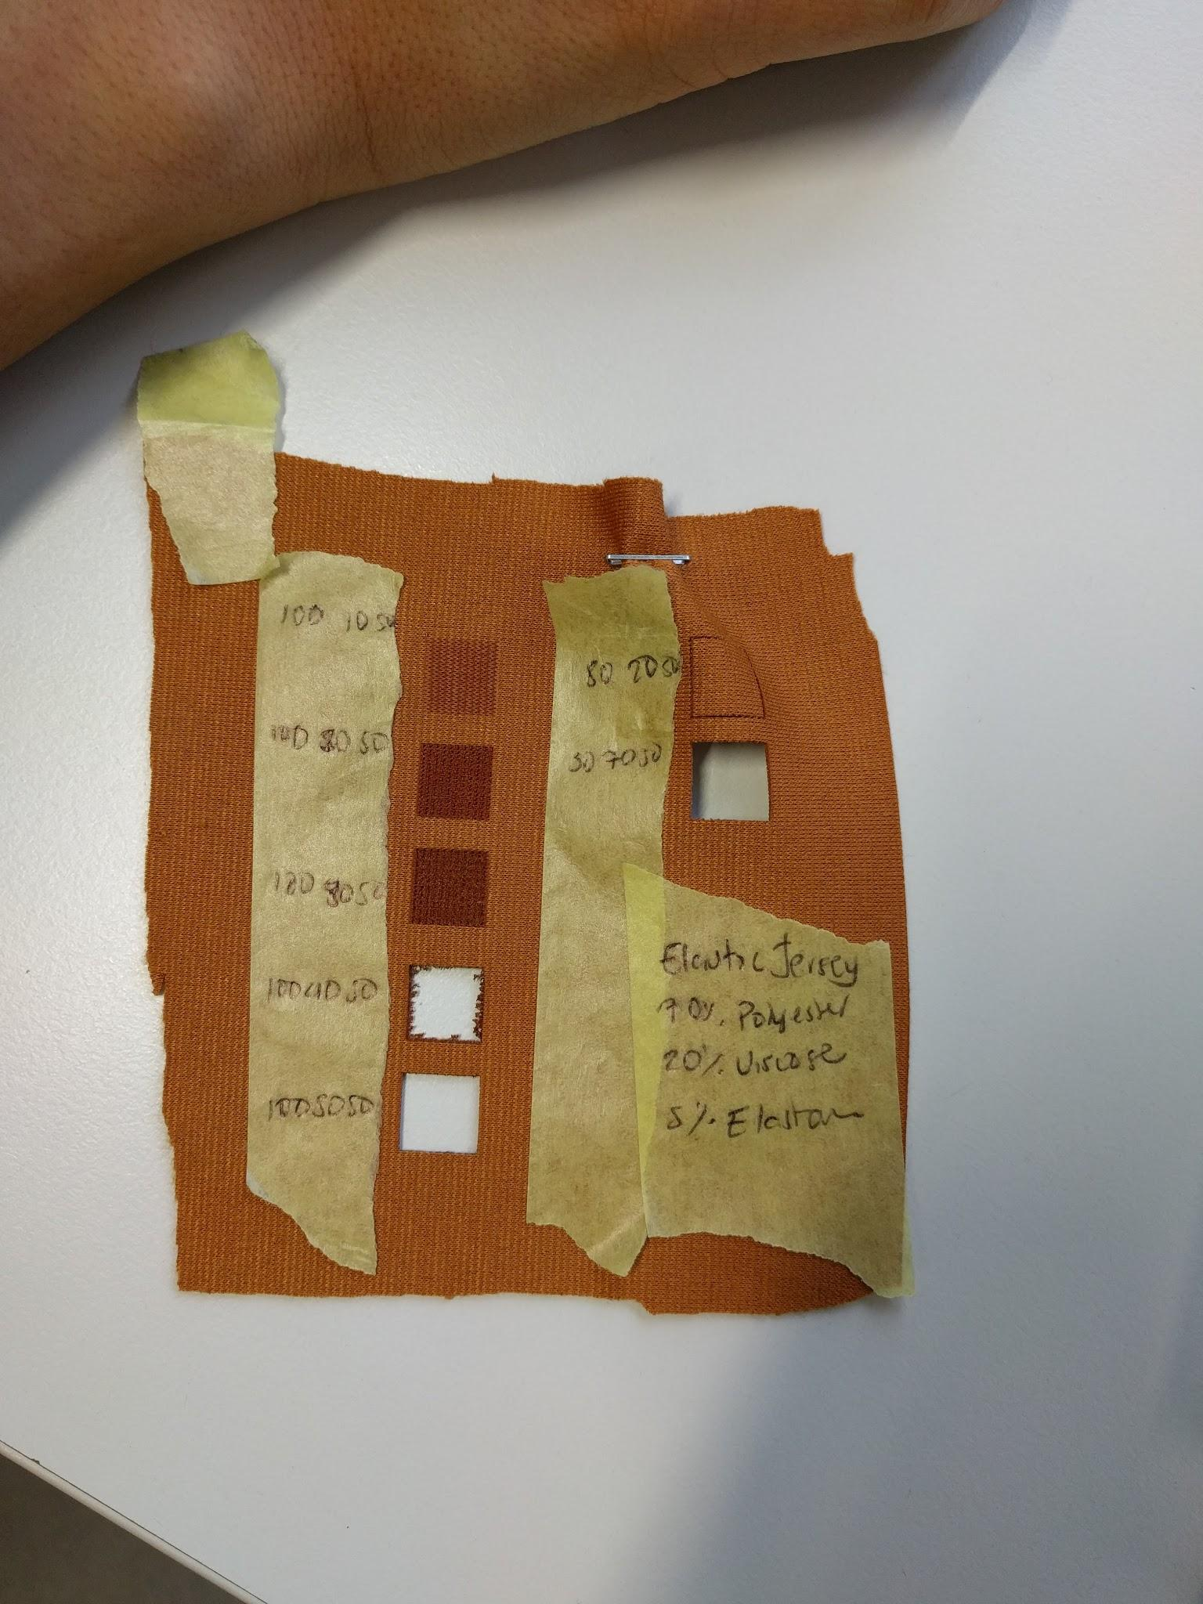

Photo 1.1: An example of how different configurations affect the appearance of the cut and engraved areas on elastic jersey, prepared by Adriana for the tutorial

Our assignment for the day was to design 2D interlocking patterns that can be useful later for our final project. We are allowed to use any 2D design software of choice, but Adriana also did a tutorial in Rhinoceros and showed us how to send the design from Rhino to the laser cutter for cutting or engraving.

As I intend to do a bracelet/ wristband for my final project, I design a simple wave pattern that can be kind of weaved together in varying quantity to form an extendable piece of wearable.

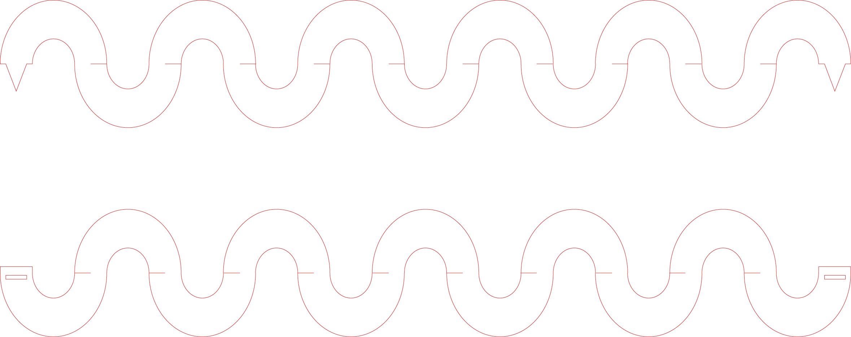

Photo 1.2: 2D interlocking pattern designed in Adobe Illustrator

I have also found inspiration from a [scale pattern](http://shinoonodera.com/post/65317472329/amune-original-product-graduation-works) by Shino Onoreda which can also be weaved together to form flexible and extendable surfaces and tried to design it in Illustrator.



Photo 1.3: Scale pattern inspired by Shino Onoreda

Finally, at the end of the day, some fellow Textile Academy 2016 participants of Adriana, who are working on their research project in bacteria dying at the Waag Society - Amsterdam, payed us a visit and also showed us some of their beautiful work pieces.

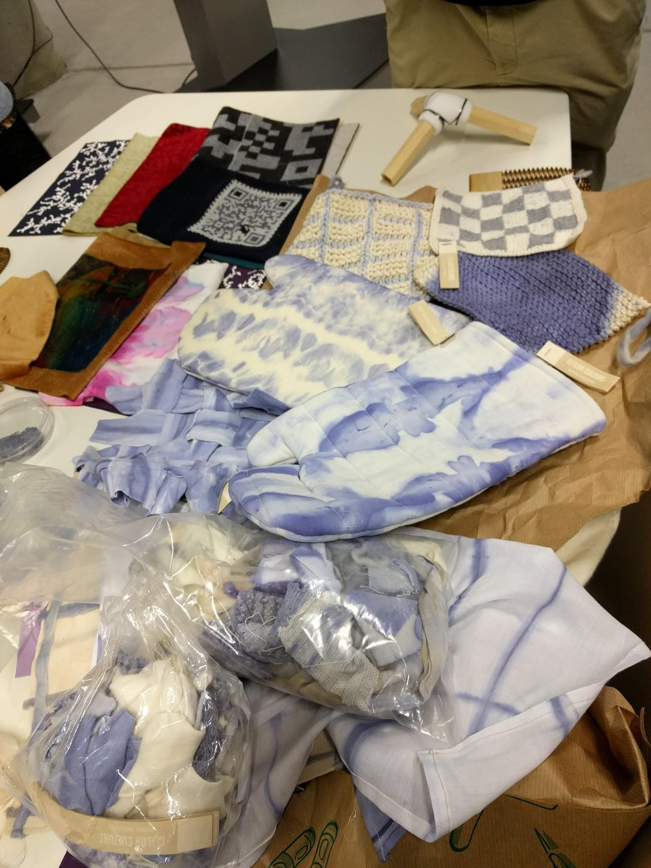

Photo 1.4: Samples of various types of fabrics dyed with bacteria, including cotton, silk, linen, wool, thread, etc.

They also shared with us their working experiences with the bacteria dyes, for example, the temperature required for the bacteria to grow in its nutrient solution is around room temperature (26°C), how the shade of the dye depends on not only the type of fabric or the mordant used with it but also how long we leave the fabric inside the petri dish containing the bacteria (more discussed later on Day 2).

## 

## 

## 21.02.2017 - Day 2: Producing bioplastics and composites, molding and casting workshop

We started off with a lecture from Cecilia Raspanti, one of the main figures of Waag Society Amsterdam, on [using microbes for dying](https://www.youtube.com/watch?v=adLfZcsE7UA).

It turns out that the bacteria that gives the violet dye color that we saw the day before (photo above) is called the [Janthinobacteria](https://www.google.de/search?q=Janthinobacterium&source=lnms&tbm=isch&sa=X&ved=0ahUKEwiA98q31K7SAhWEliwKHdalBi4Q_AUICCgB&biw=1280&bih=591). As Professor Daniela Lud - one of the participants - explains, while growing, this bacteria produces the same pigment that can be found in the [Pansy flower](https://www.google.de/search?q=pansy+flower&source=lnms&tbm=isch&sa=X&ved=0ahUKEwiIqoC_w67SAhVIMJoKHWyWCQUQ_AUICCgB&biw=1280&bih=591). The culture medium for the bacteria is a mixture of glycerin, broth powder and water. When growing the bacteria in the lab, although it is a safety level 1 bacteria, **care must be taken to keep all tools and material sterilised so that we only favour the growing of this bacteria but not other bacteria in the surroundings**. As such, we were not able to carry out the bacteria dying experiment by ourselves but Professor Lud and Adriana prepared them in the University’s Bio Lab for us instead.

The shade of the dye on fabric depends on the temperature, the amount of oxygen available for the bacteria, the type of textile fiber. For example, protein-based fibers like cotton usually get dyed easily while cellulose-based, vegetable fibers like silk, linen have to be dyed in a different way because of their layering structures.

One can also dye fabric using natural dyes from plants such as turmeric, berberis, black beans, red cabbage, tea, lichens, bloodroot, coffee, onion skin, etc. Mordants such as allum, copper liquor, iron liquor are combined with a dye bath to enhance the fastening process of the dye onto organic fibers, both protein and cellulose based. The interesting thing is, by using different fabrics and different concentrations or types of mordants, one is able to produce **various shades of a pigment using the same natural dye**.

Next, we had a workshop on making composites by Thomas Kropp, an employee here in HSRW Kamp-Lintfort. He used a half-body mannequin made out of clay as a mold for the composite. First, he covered the mold with textile (in this case, [jute fabric](https://www.google.de/search?q=Jute+plant&source=lnms&tbm=isch&sa=X&ved=0ahUKEwjWstHLyK7SAhXrO5oKHTcXDAoQ_AUICCgB&biw=1280&bih=591#tbm=isch&q=Jute+fabric&*)), combined [polyester resin](https://www.google.de/search?q=Jute+plant&source=lnms&tbm=isch&sa=X&ved=0ahUKEwjWstHLyK7SAhXrO5oKHTcXDAoQ_AUICCgB&biw=1280&bih=591#tbm=isch&q=Polyester+resin&*) and [resin hardener](https://www.google.de/search?q=Jute+plant&source=lnms&tbm=isch&sa=X&ved=0ahUKEwjWstHLyK7SAhXrO5oKHTcXDAoQ_AUICCgB&biw=1280&bih=591#tbm=isch&q=resin+hardener&*) in a certain ratio (as described on the packaging) and then evenly applied the mixture on the textile. It is recommended to get all tools ready and apply the mixture quickly on the textile before it hardens which can make it difficult to proceed.

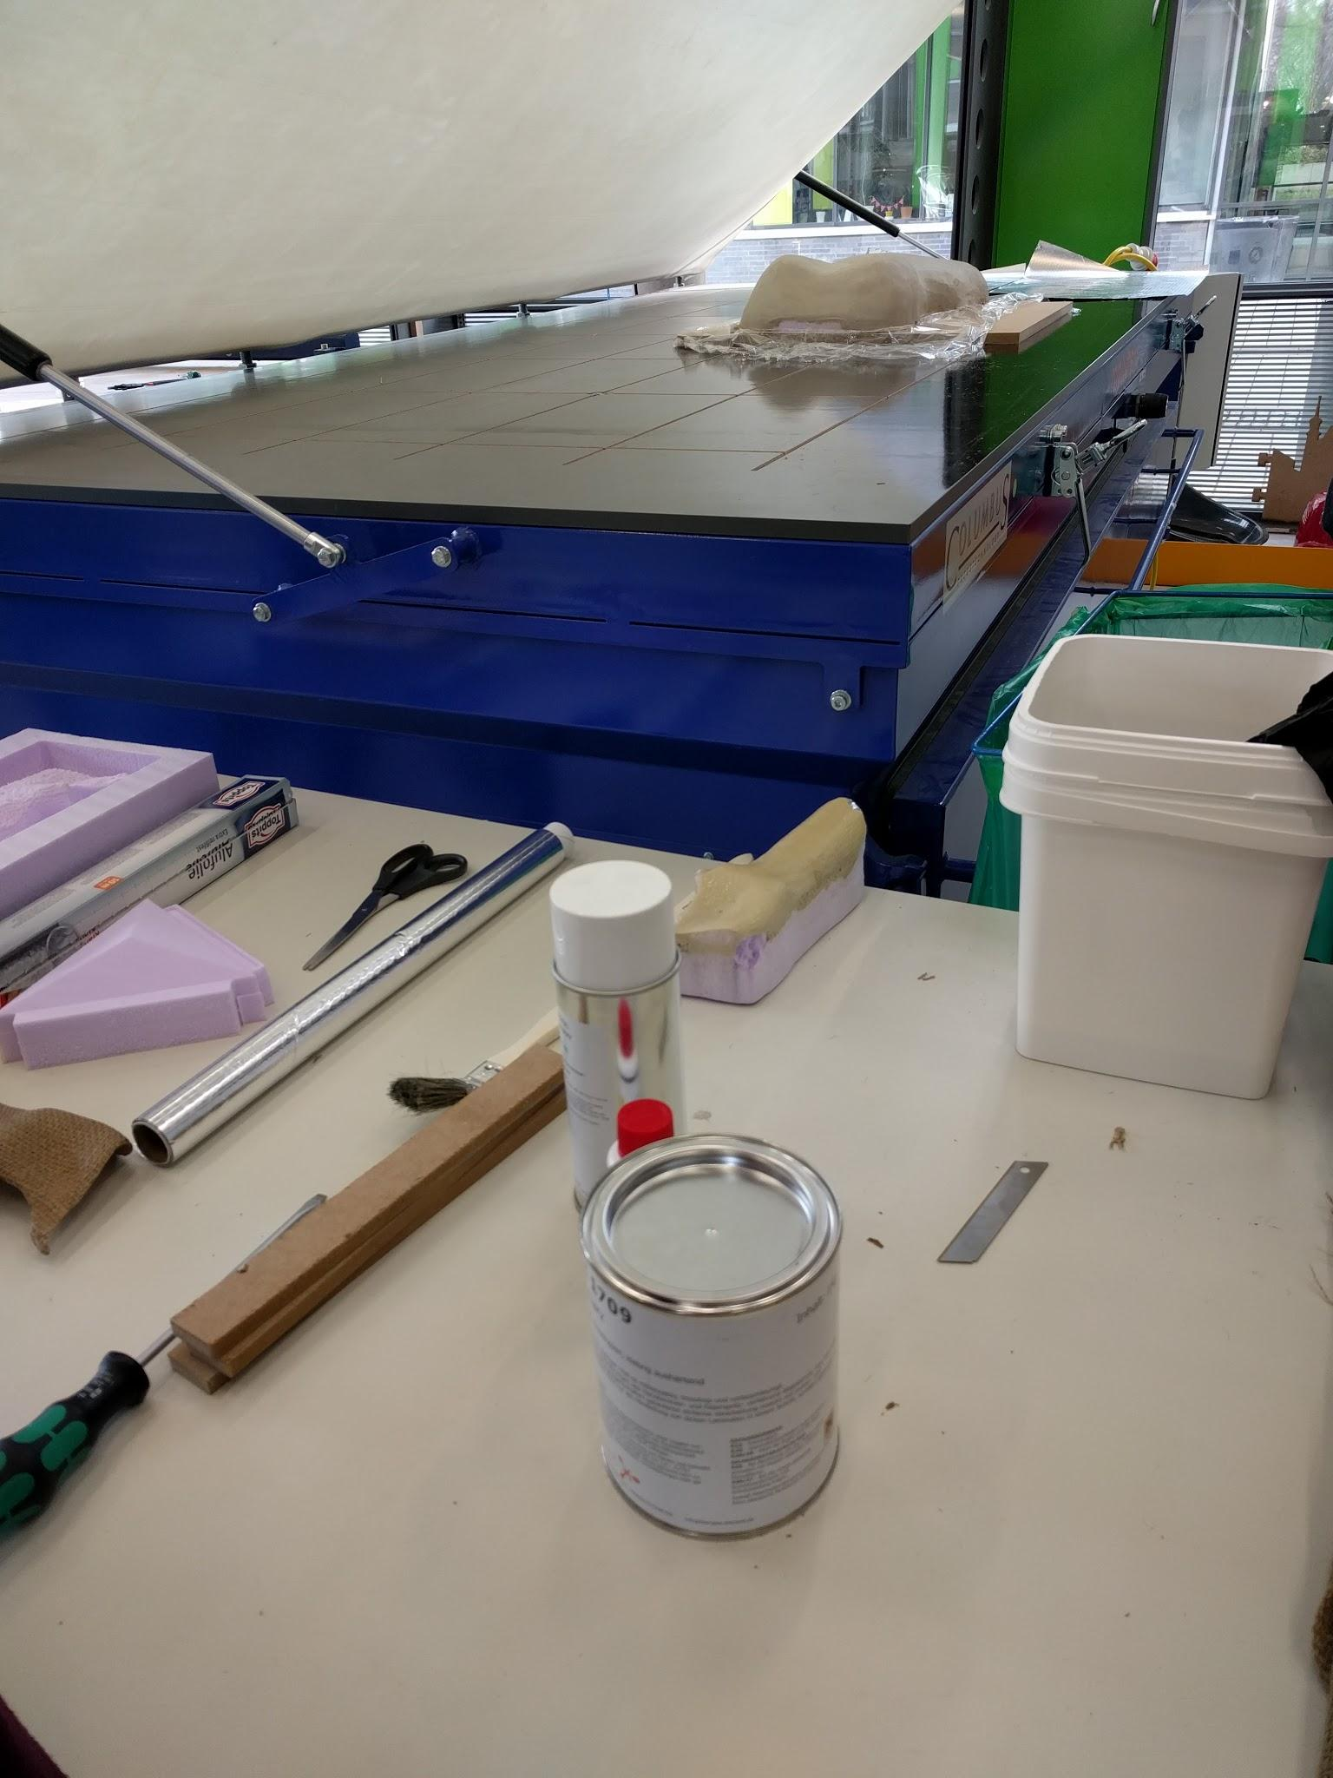

Photo 2.1: Combine polyester resin and hardener in a bucket

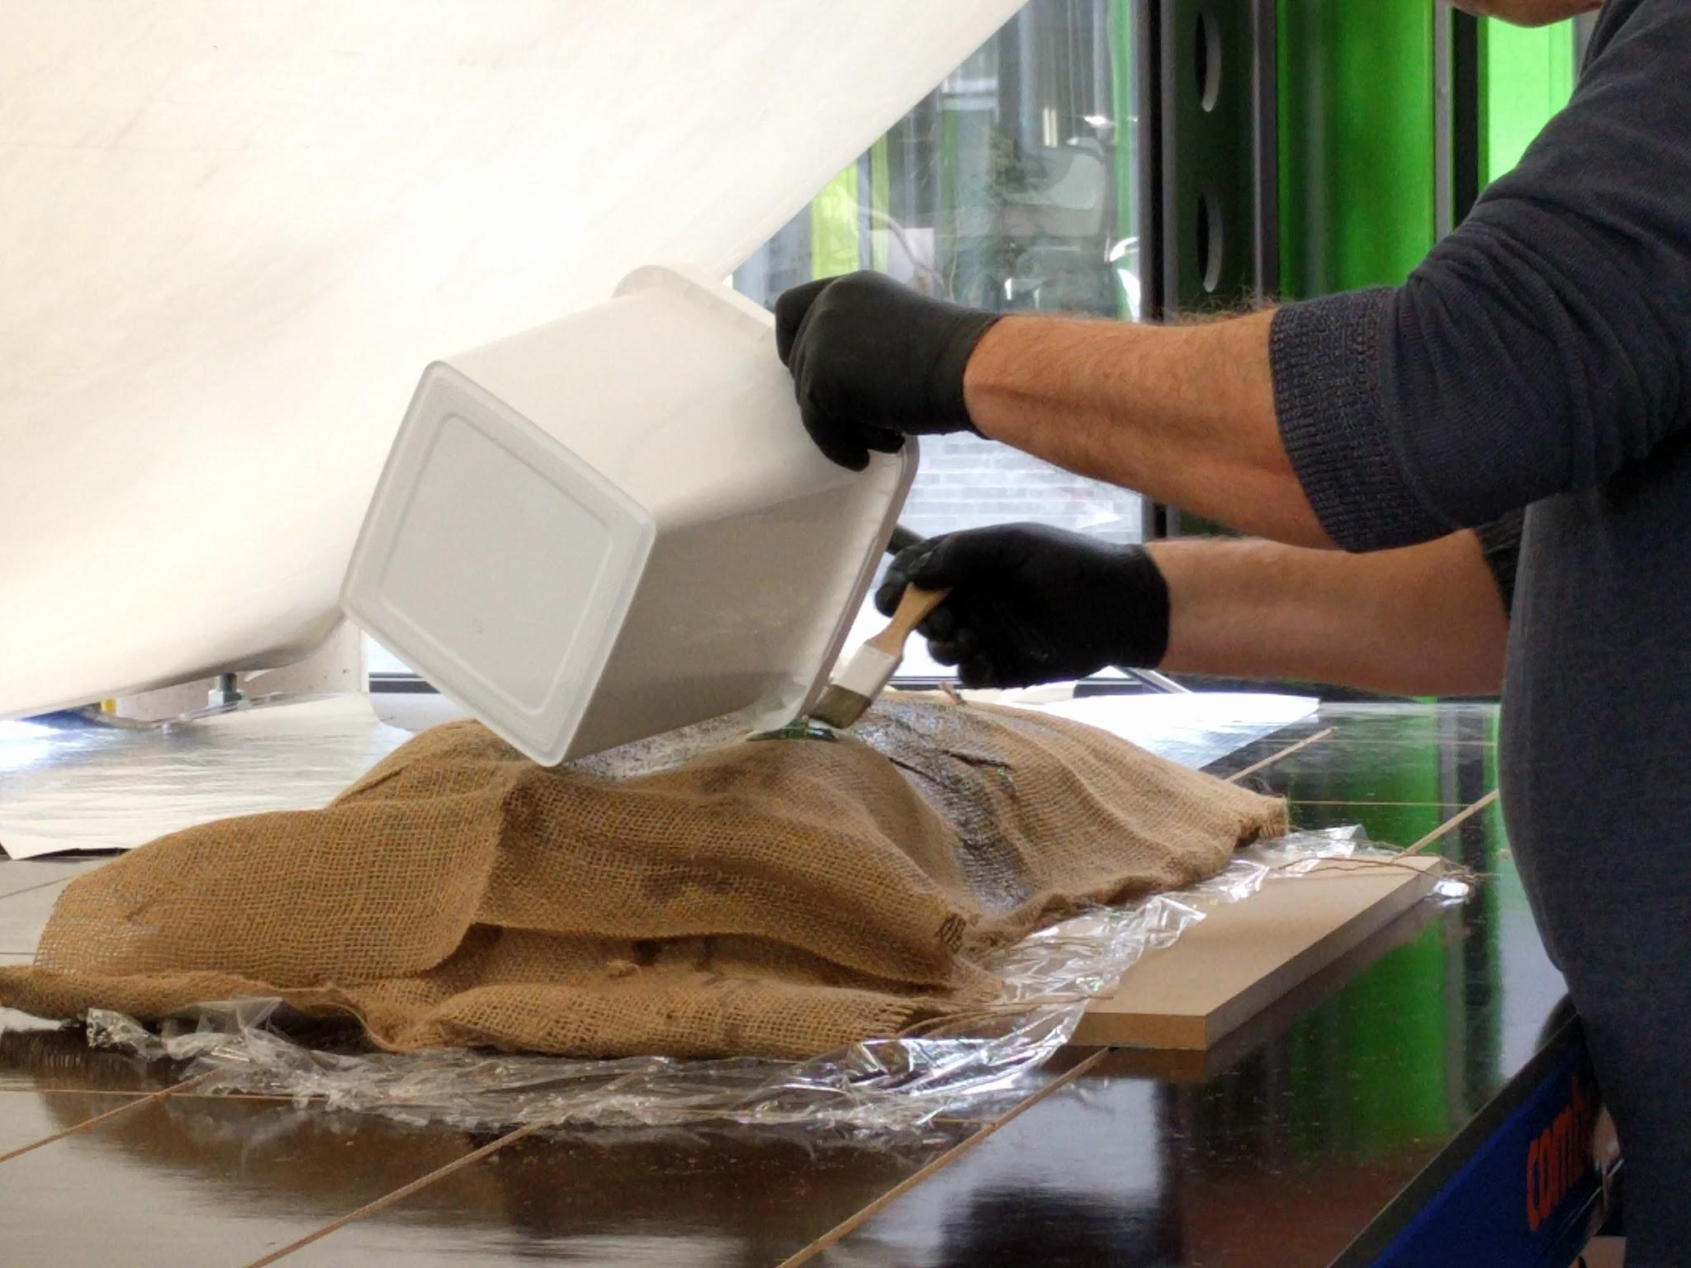

Photo 2.2: Cover the mold with aluminum foil, then with textile and then apply the mixture evenly with a brush

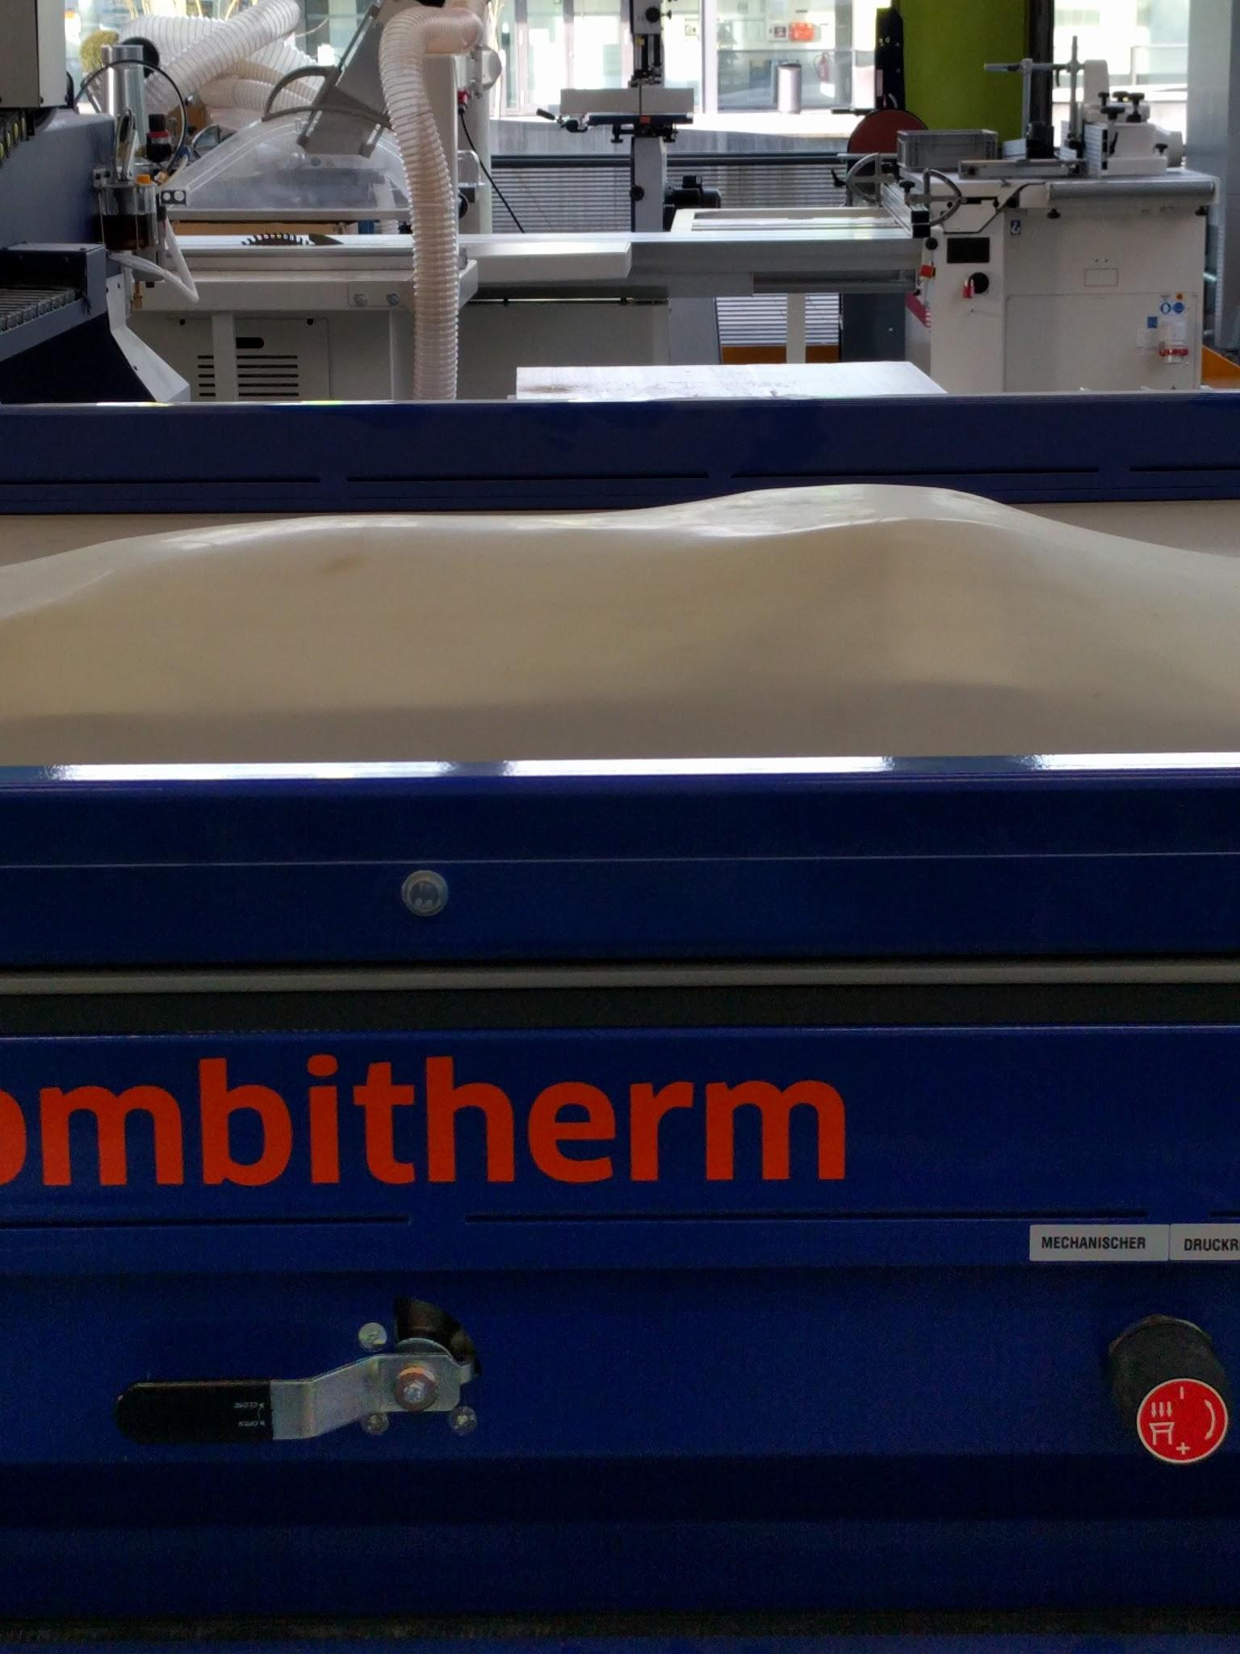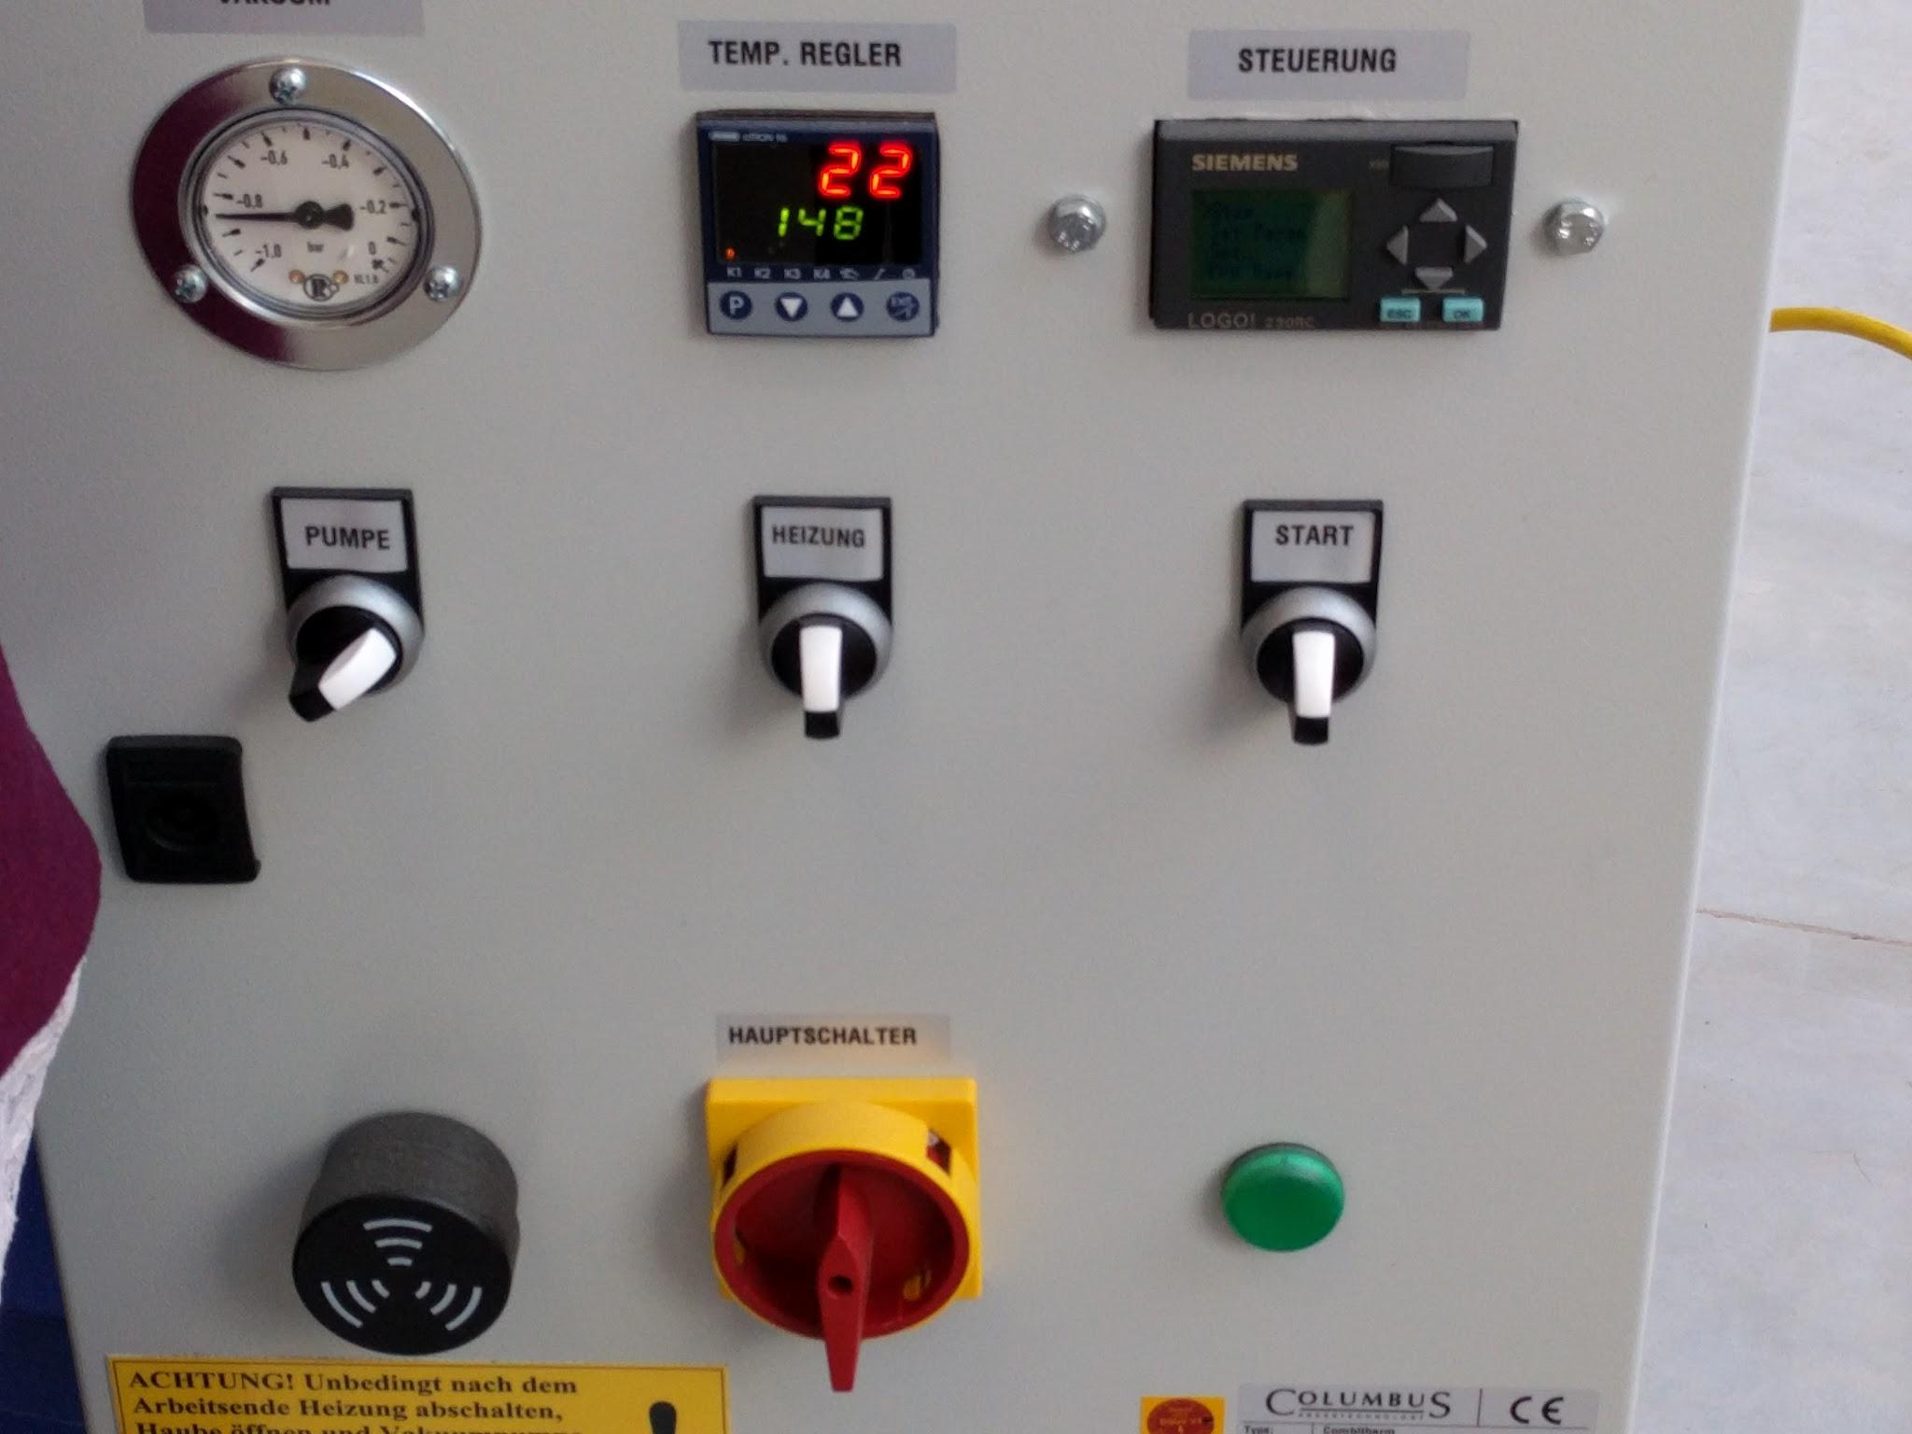

Photo 2.3-2.4: Finally, cover the composite with more aluminum foil and let it be vacuum pressed with the correct machine settings for around 30 minutes. Let it dry afterwards.

Next is producing biomaterials in the kitchen using very ordinary materials like sugar, water, gelatine, liquid glycerin, or even milk. This is really the exciting part because the final plastic will be degradable but can still be used to form different shapes, or can even be laser cut.

For the very fast and easy [Kombucha](http://www.futurity.org/scoby-fabric-kombucha-leather-1149392-2/) recipe, we **boiled 1.5L of water with around 170g sugar and a few bags of black tea and slowly add vinegar with 5% acidity until the pH of the mixture becomes around 6.0**. After waiting for the solution to cool down to around 36°C, we simply transferred the solution to a plastic box and added a small piece of live Kombucha (or SCOBY) that Adriana had prepared beforehand. Now the bacteria is ready to grow in this culture medium and produces more fabric/plastic by itself.

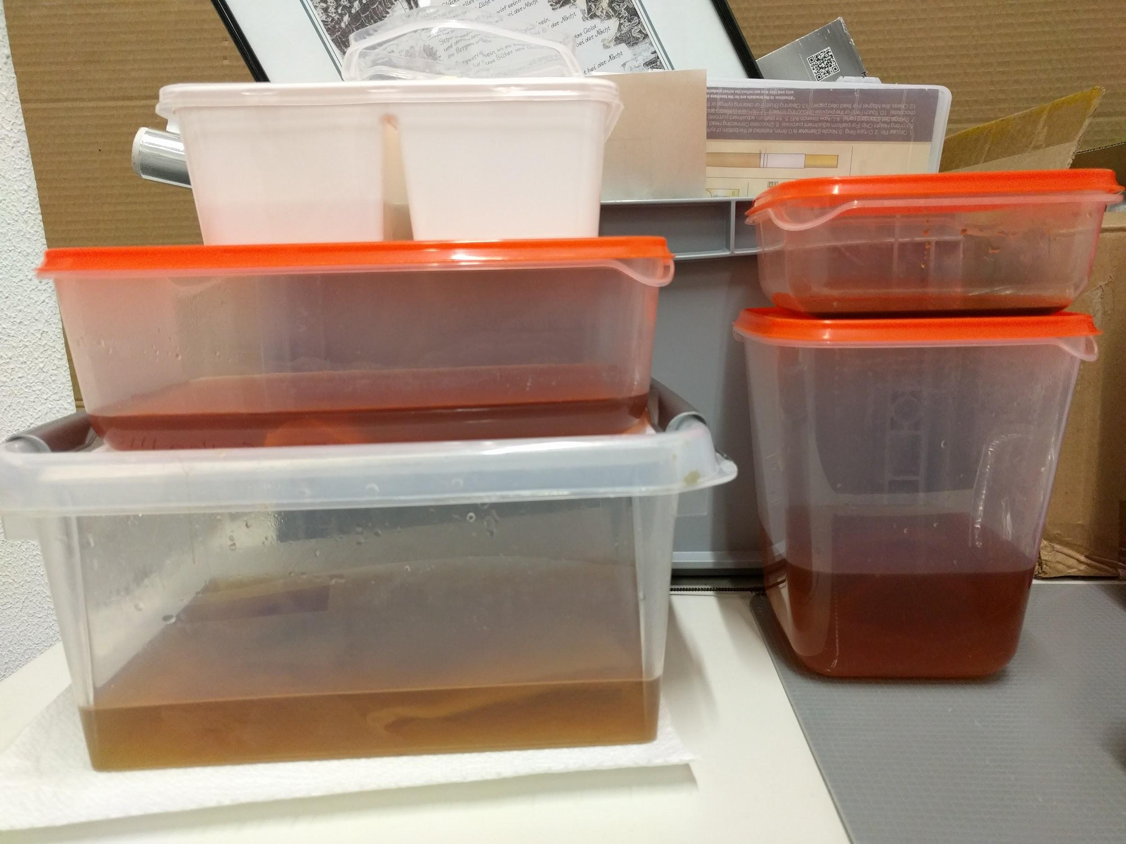

Photo 2.5: Plastic box containing live Kombucha in nutrient solution for growing fabric

## 22.02.2017 - Day 3: 3D Printing and 3D Scanning Workshop

I could not attend this session because of my part-time job. However, during the next day Adriana also did a recitation of 3D modelling and how to construct 3D model from a 2D design in Rhino.

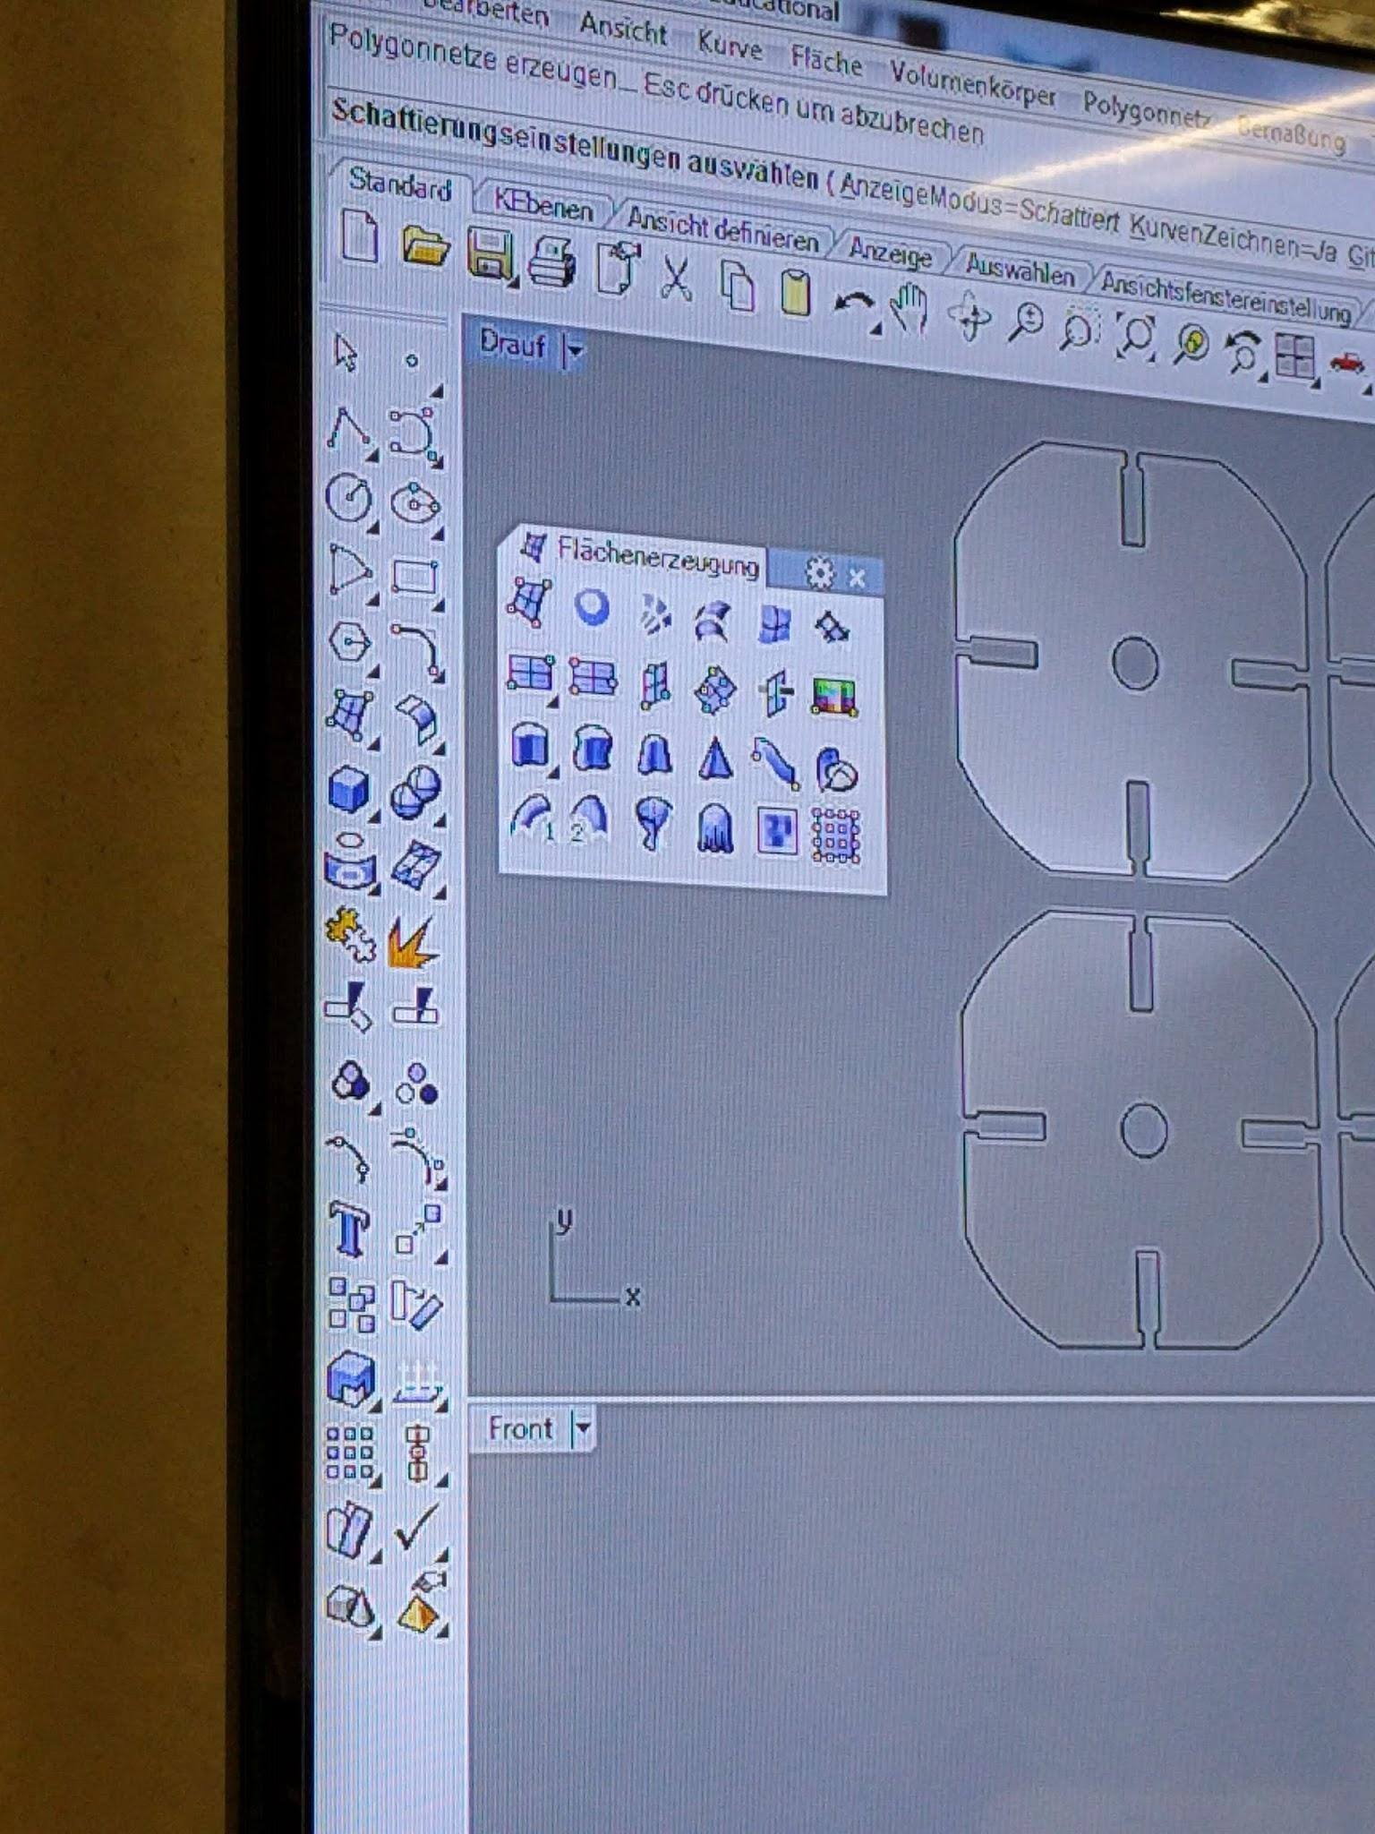

Photo 3.1: Construct 3D structure out of a 2D design in Rhino

Also, another employee of the FabLab, Daniele Ingrassia, showed us the steps to print a 3D model using one of the biggest 3D printer, the Big Rep ONE.

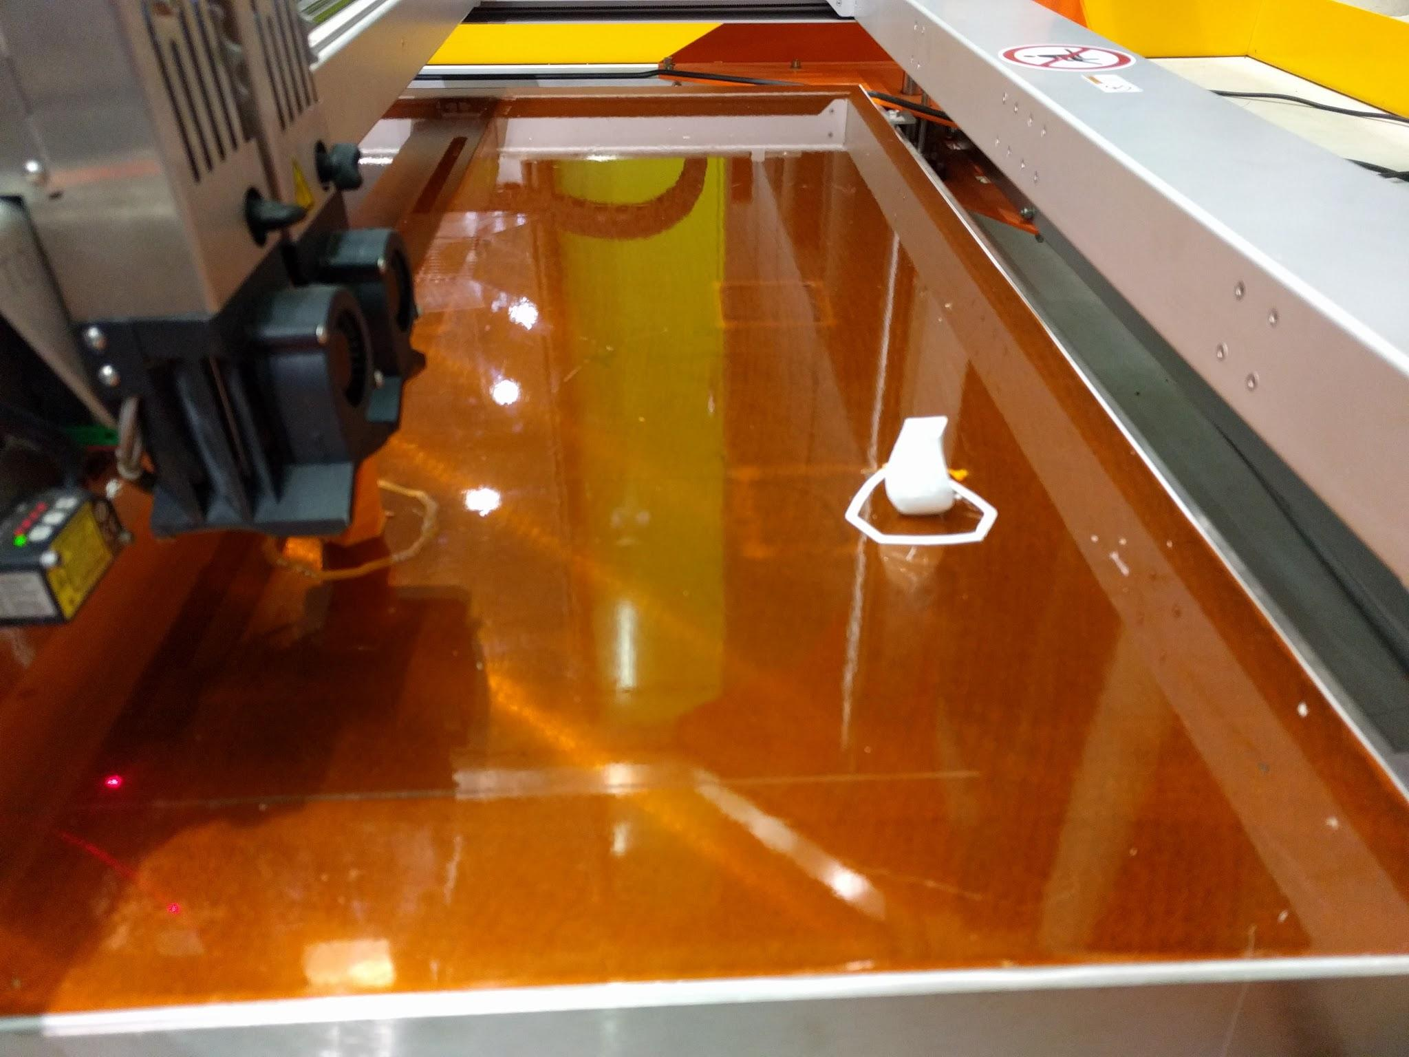

Photo 3.2: A sample print using the Big Rep ONE

## 

## 

## 23.02.2017 - Day 4: Embedded electronics on textiles

The point of today was to experiment various ways of turning textile into an interface for human interaction with technology.

First, we played around with the poster from Jana, one of the participants, who combined **screening printing** techniques and **conductive ink** ([Bare Conductive electric paint](https://www.google.de/search?q=bare+conductive+touch+board&source=lnms&tbm=isch&sa=X&ved=0ahUKEwjEvaS04K7SAhXmK5oKHW_SBjkQ_AUICigD&biw=1280&bih=591#tbm=isch&q=bare+conductive+electric+paint&*)**)** to make the poster. When we connect certain traces on the poster to the [Bare Conductive touch board](https://www.google.de/search?q=bare+conductive+touch+board&source=lnms&tbm=isch&sa=X&ved=0ahUKEwjEvaS04K7SAhXmK5oKHW_SBjkQ_AUICigD&biw=1280&bih=591), plug in a loudspeaker, load the program onto the board, we could play melodies by touching some certain spots on the poster. These can all be defined in the program, so it is like a huge printed circuit which makes it highly attractive and easy to interact with.

Afterwards, we made our own **DIY Capacitive Sensor just using copper foil, jumper cables and clear tape**. We wired up the sensor to the Arduino board with a 1M Ohm resistor and experimented reading the sensor values in Arduino IDE using the [Capacitive Sensor library](http://playground.arduino.cc/Main/CapacitiveSensor?from=Main.CapSense) and were able to control outputs like LEDs with the sensor.

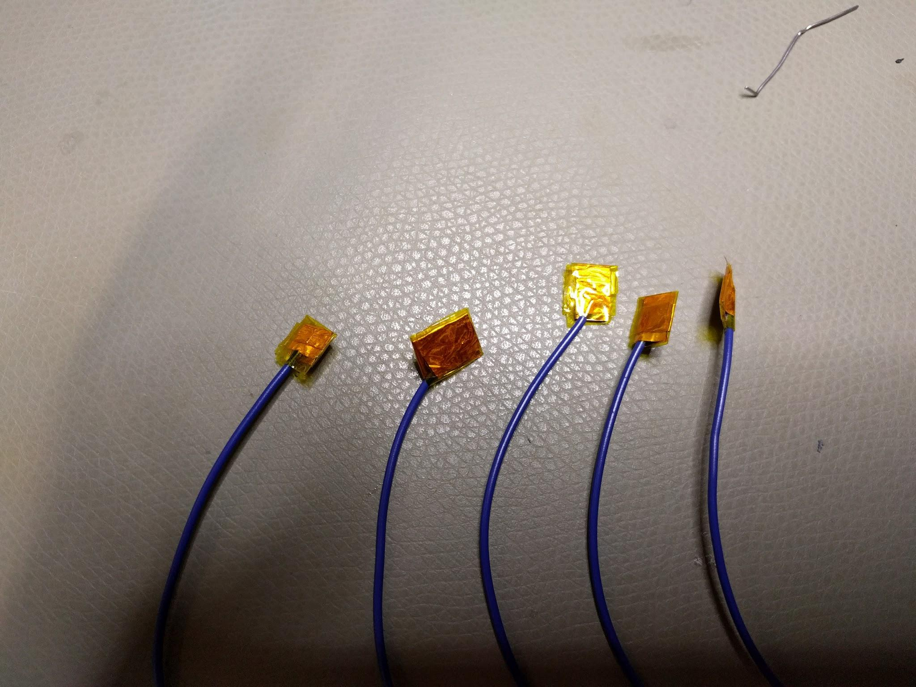

Photo 4.1: DIY Capacitive sensors using copper foil, jumper cable and Kapton tape

I also prepared an example where one can control a [Neopixel Ring](https://www.adafruit.com/products/1643) with a pressure sensor made out of the [DIY Sensor film kit](https://www.adafruit.com/product/1917) from Adafruit Industries.

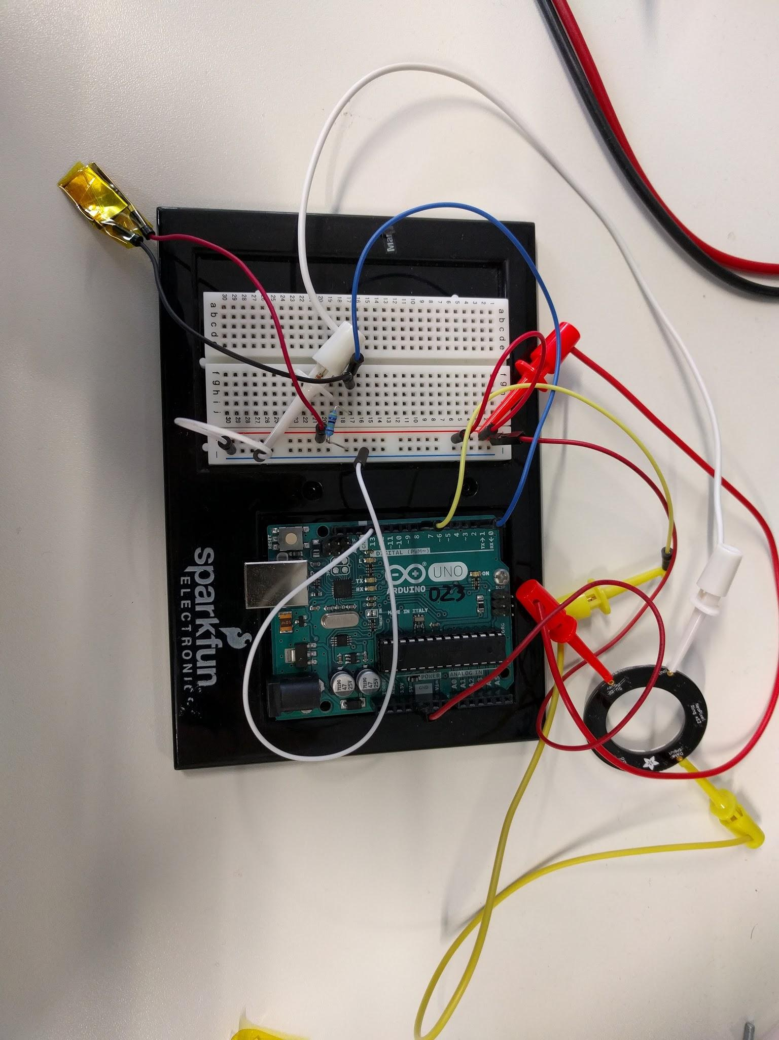

Photo 4.2: Circuit to control Neopixel ring using DIY pressure sensor

Afterwards, these sensors can be easily integrated into textiles to control different output devices including LEDs, servos, motors, or even household electronic devices like lamps.

## 

## 

## 24.02.2017 - Day 5: Final project “Interactive musical wristband”

Initially, the idea for my final project was to laser cut the wave patterns (Photo 1.2 from Day 1) and weave them together to make a bracelet, and embed a [Contactless Thermopile Infrared Temperature Sensor](https://www.adafruit.com/product/1296) from Adafruit Industries, a loudspeaker, and a compact microcontroller like the [Sparkfun Lily Tiny](http://www.exp-tech.de/sparkfun-lilytiny) or similar. It will function as a **safety wristband** which will ring an alarm when the hand is near to a hot object or surface and may get burnt by contact with it. For example, in the FabLab we have to work a lot with 3D printers which have hot printing bed as well as hot extruders. As such, one always have to pay attention not to touch these spots. But sometimes, we are too excited to get our newly 3D printed model out of the machine and forget about safety instructions. The wristband would come in handy in such cases.

I have tried cutting the wave patterns in the laser cutter on 1.0mm felt:

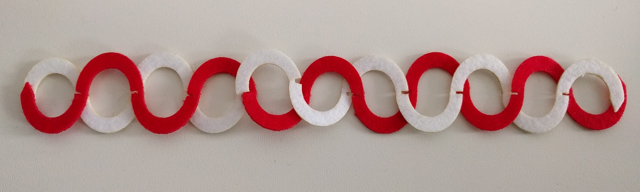

Photo 5.1: Interlocking wave patterns laser cut on 1.0mm felt of different colors

I have also tried printing the scale patterns (Photo 1.3 from Day 1) using different types of filaments as an alternative for my wristband because throughout the day the laser cutter was occupied by other participants and I think it was not so urgent for me to use the machine.

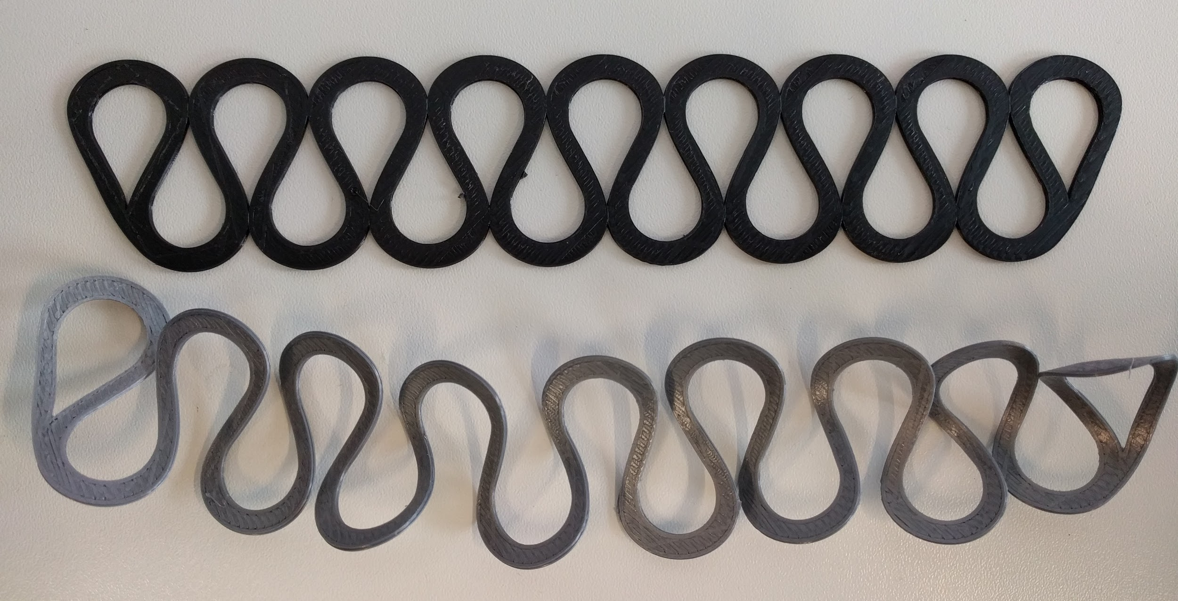

Photo 5.2: Scale patterns printed with normal PLA filament (black, top) and flexible PLA filament (grey, bottom)

Finally, I found it interesting to combine the normal and the flexible filaments to form a structure that is flexible but still gives rigid form to textile:

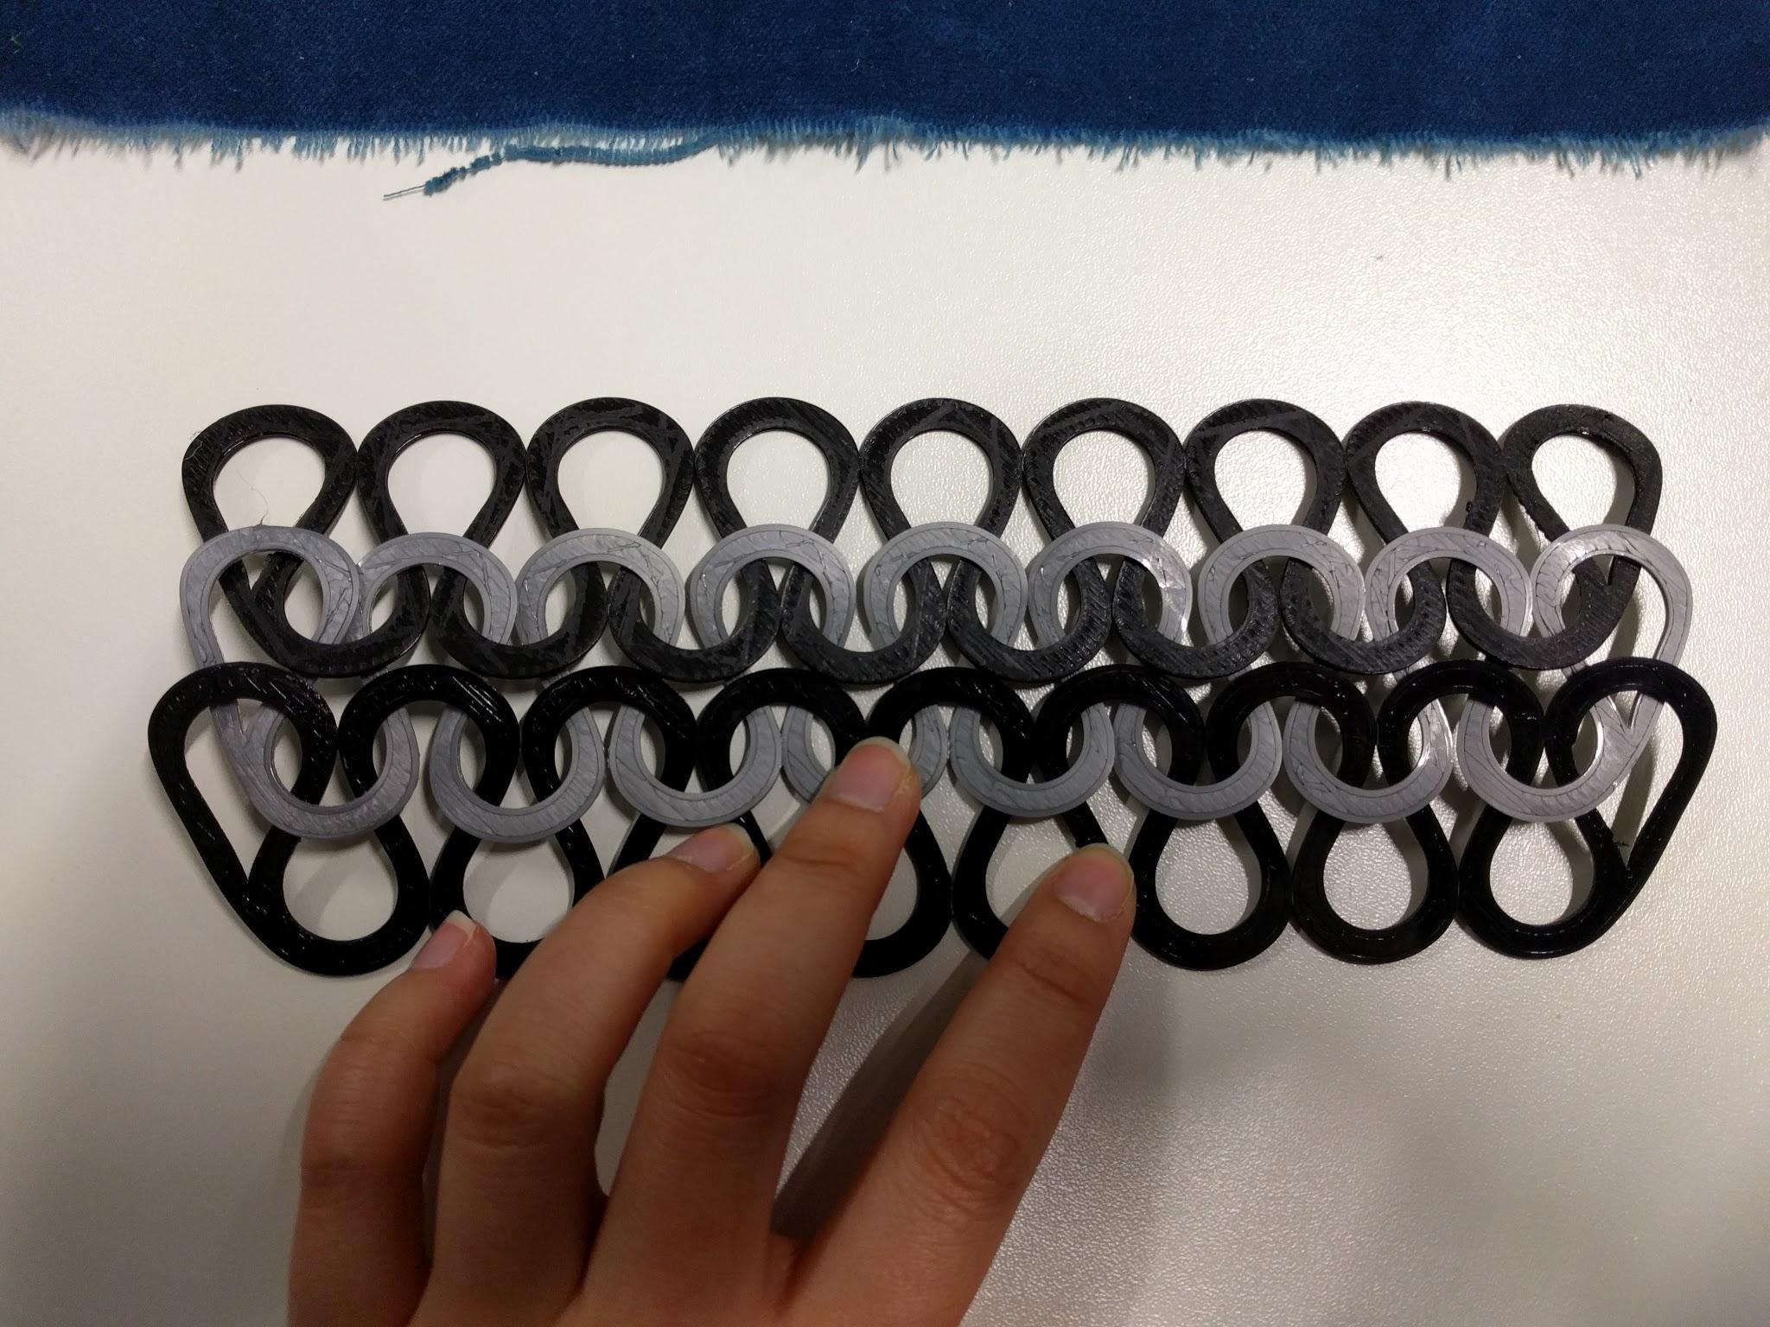

Photo 5.3: Extendable structure using both rigid and flexible patterns

Thus I have decided to proceed with this scale pattern for my bracelet.

Also, being inspired by the interactive poster from Jana which can play melodies through touching, I challenged myself to do something similar instead. This would make the wristband more fun to interact with and not so passive as a temperature sensor. Instead of playing fixed programmed melodies, I would prefer the wristband to **let users compose their own melodies with different musical notes** by touching different spots on the textile.

Using an [Arduino Pro Micro](http://www.exp-tech.de/pro-micro-5v-16mhz) (which can replace Arduino UNO for this project’s purpose but is more compact and also easy to reprogram through its micro-USB port), I would be able to wire up 1 loudspeaker, 1 Neopixel and easily up to 12 capacitive sensors, meaning **the wristband can play up to 12 different musical notes**.

I started out with creating a few sample DIY capacitive sensors for testing the circuit and the Arduino sketch.

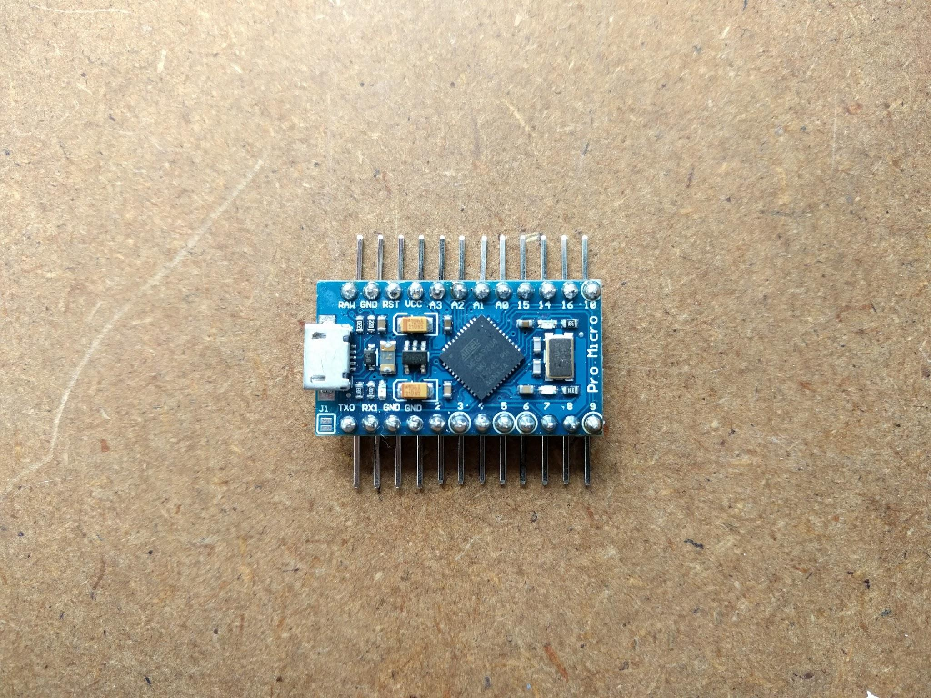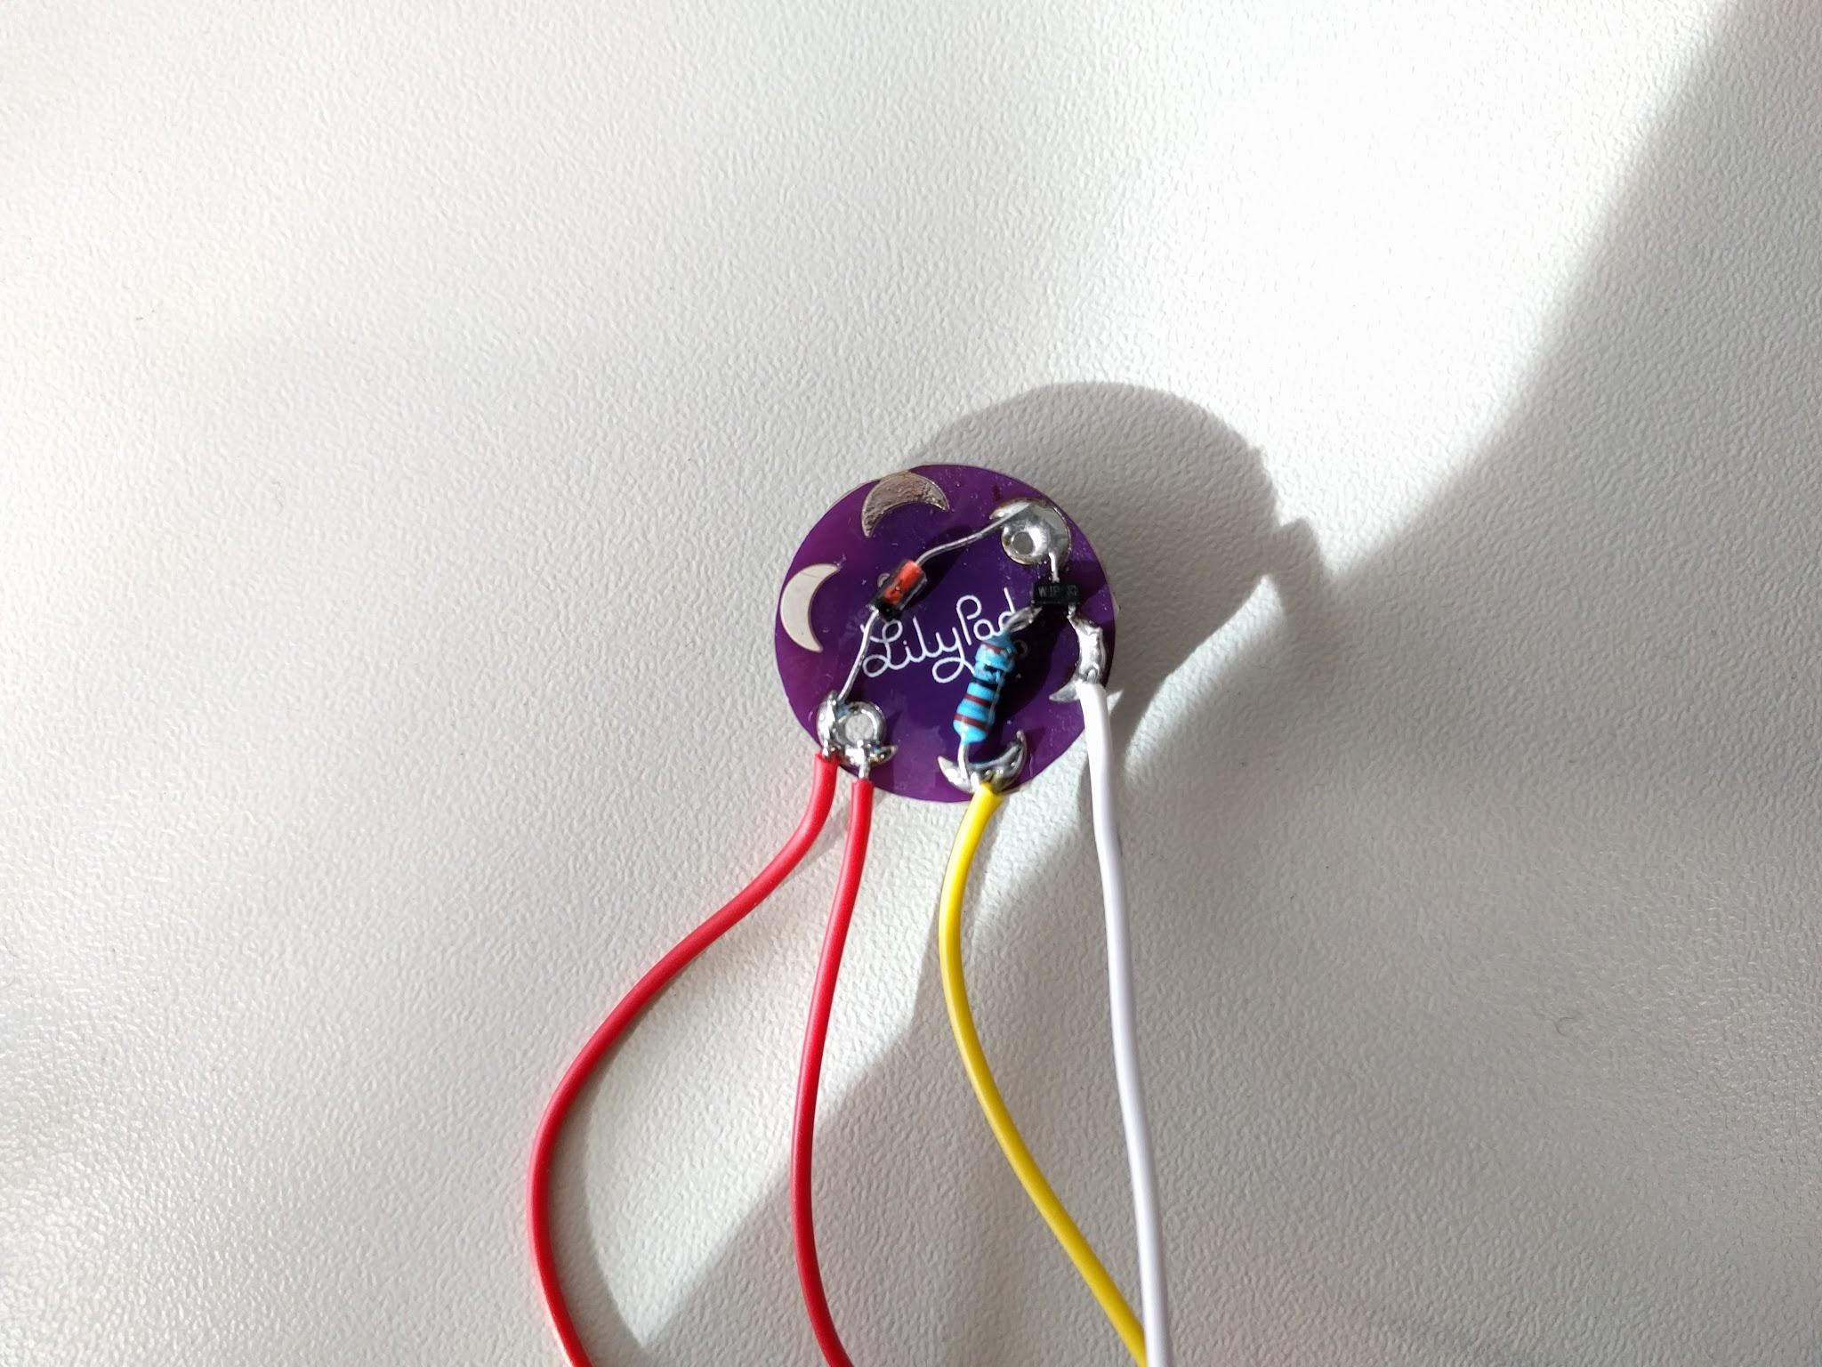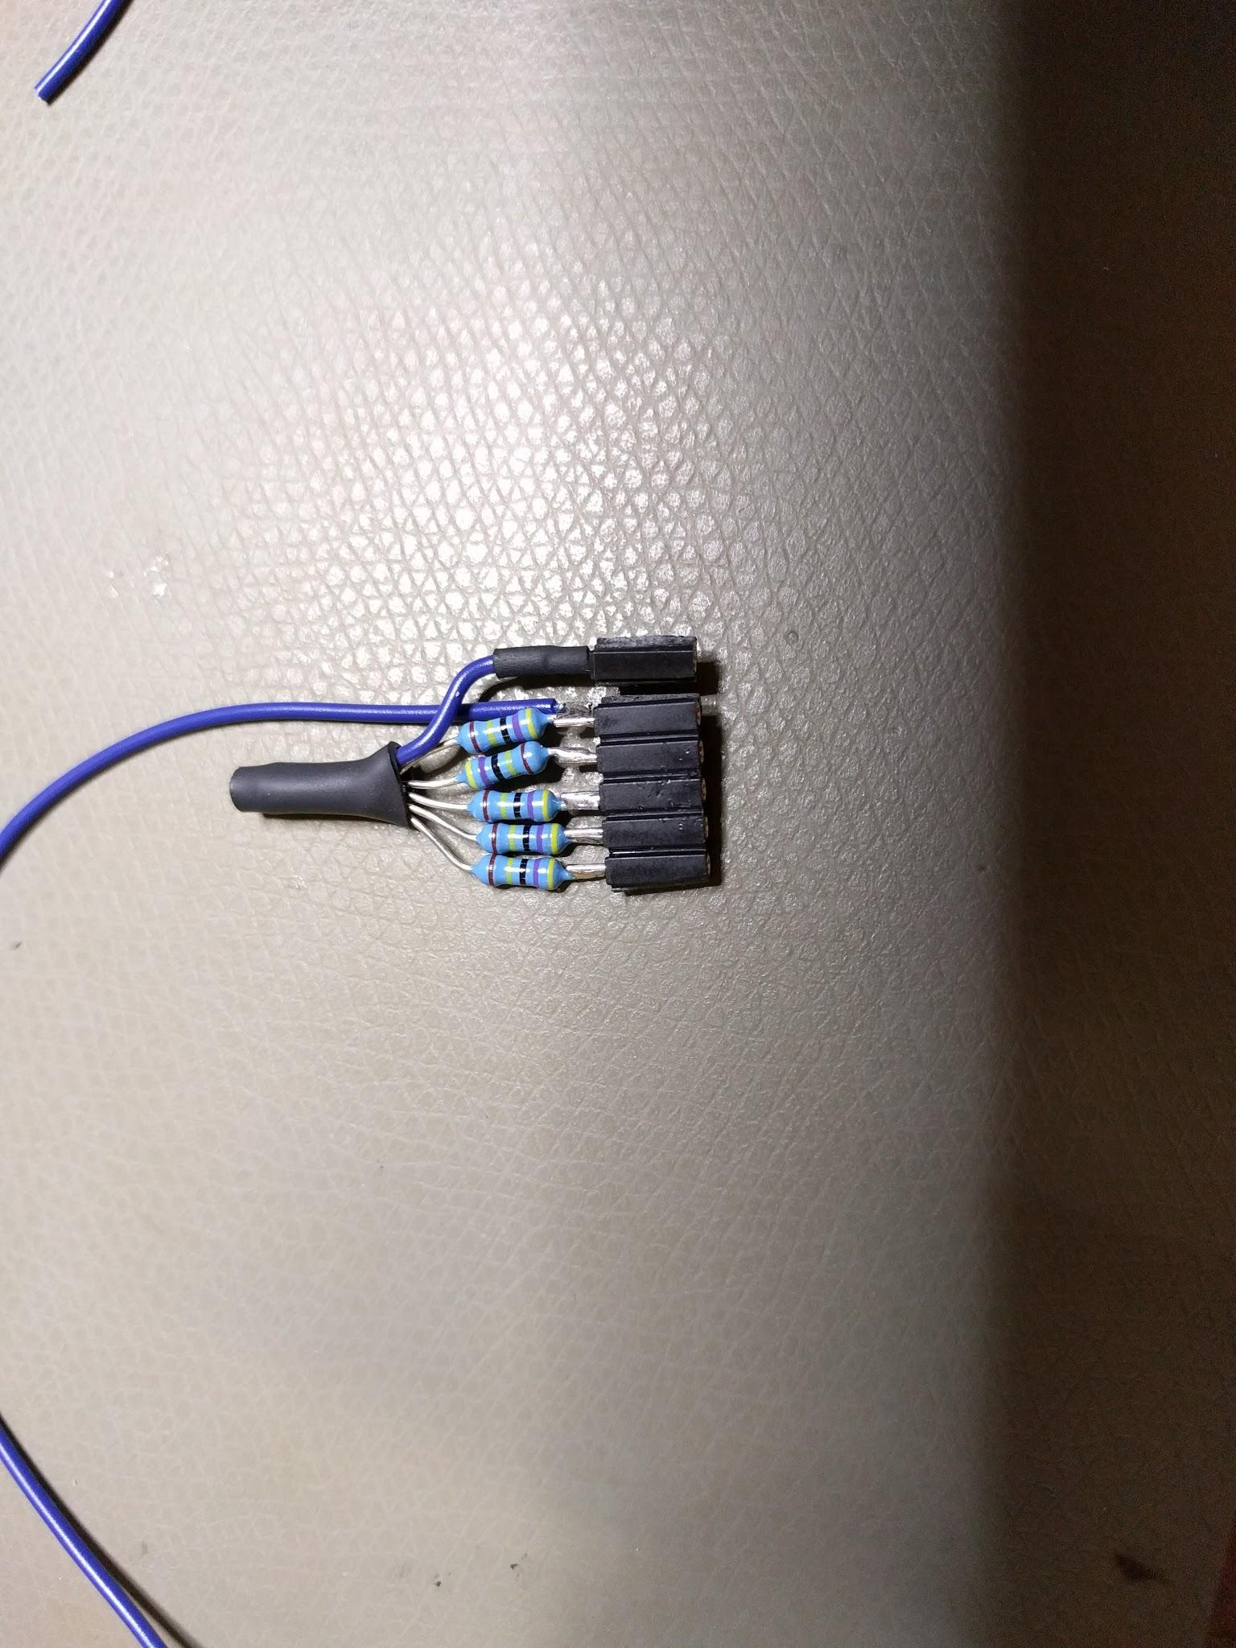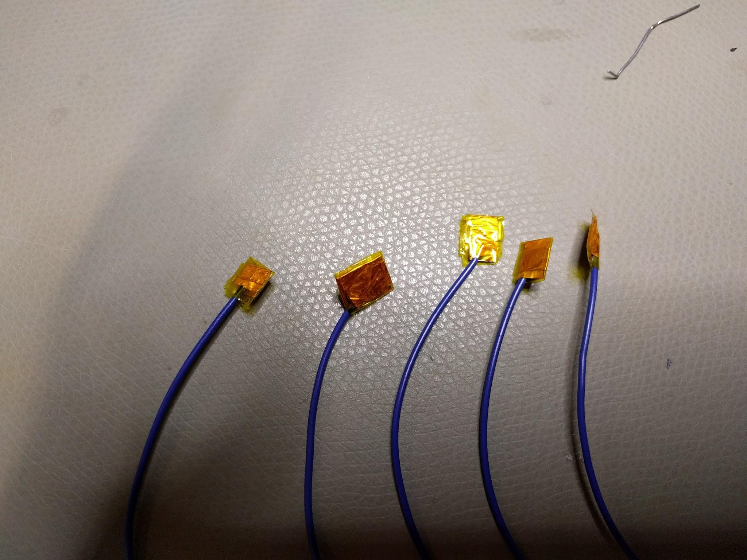

Photos 5.4a-5.4d: Steps to prepare the main necessary components for testing the circuit and the Arduino sketch

From top to bottom, left to right:

a. Solder pin headers to the Arduino Pro Micro. I use 90° male pin headers here instead of the normal straight male pin headers because I want the microcontroller to be as flat as possible so that it is easy to mount on the wristband later on

b. I checked the [datasheet](http://cdn.sparkfun.com/datasheets/Components/General/CCV-084B16-CUI-datasheet-29139.pdf) of the [Lilypad loudspeaker](http://www.exp-tech.de/pro-micro-5v-16mhz) and it turns out that I have to do some extra soldering for it to function properly in this case: adding a diode, a NPN transistor and a resistor.

c. Solder resistors to the capacitive sensor pins. I use female pin headers so that I connect to the microcontroller directly without a breadboard and a 4.7M Ohm resistor for each sensor pin (according to the author of the Capacitive Sensor library, we can use resistor value of up to 10M Ohm)

d. Prepare some test capacitive sensors using copper tape, wire and clear tape like in Day 4

Next step is to wire up the test circuit and upload the sketch to the microcontroller. In this test I use only 5 capacitive sensors on pins 3, 4, 5, 6, 7 (pin 2 is only for sensor reference) and I wire the loudspeaker’s PWM pin to pin 9 on the Arduino. However, the pin numbers and the amount of sensors can be comfortably changed in the [final sketch](https://drive.google.com/open?id=0B77ddV_s5oS_U2N2VzhMVVVORmM) before uploading to Arduino.

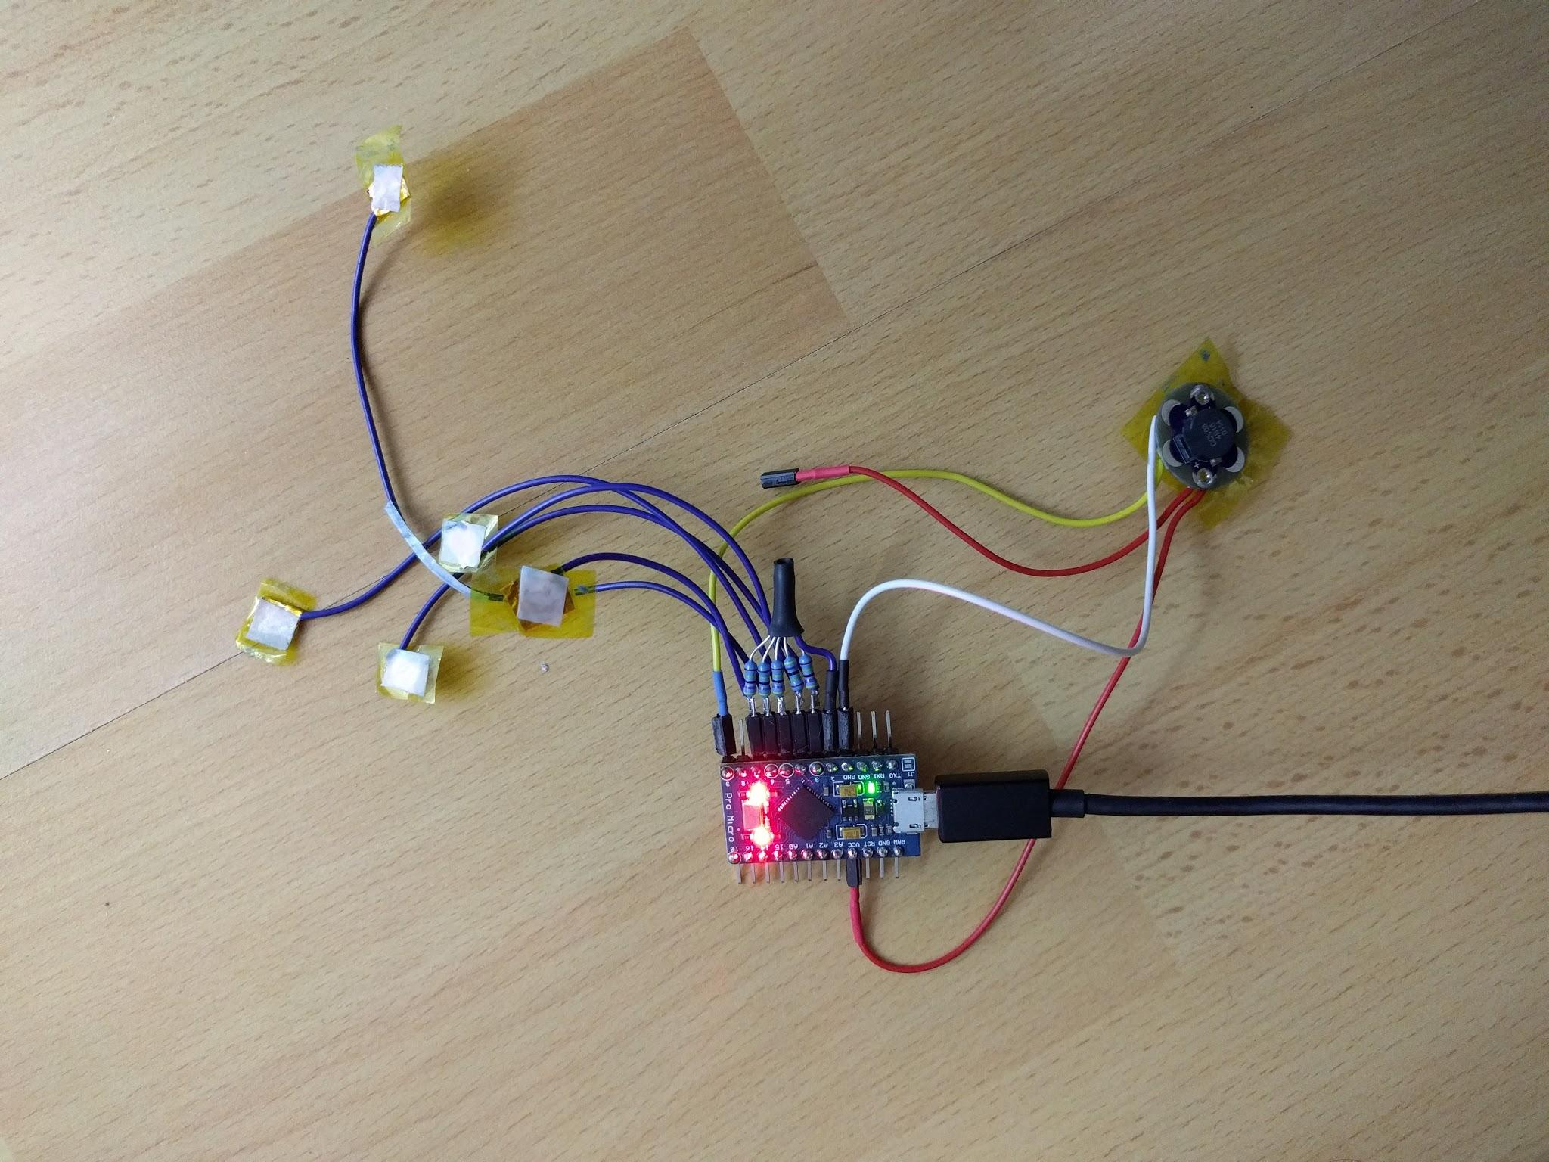

Photo 5.5: Wire up the test circuit and upload the sketch

Due to limited time, I could not make all 12 sensors on the day itself and proceeded with the textile part.

I mounted the 3D printed patterns on the textile with tape and then mount the electronic parts on it to finish:

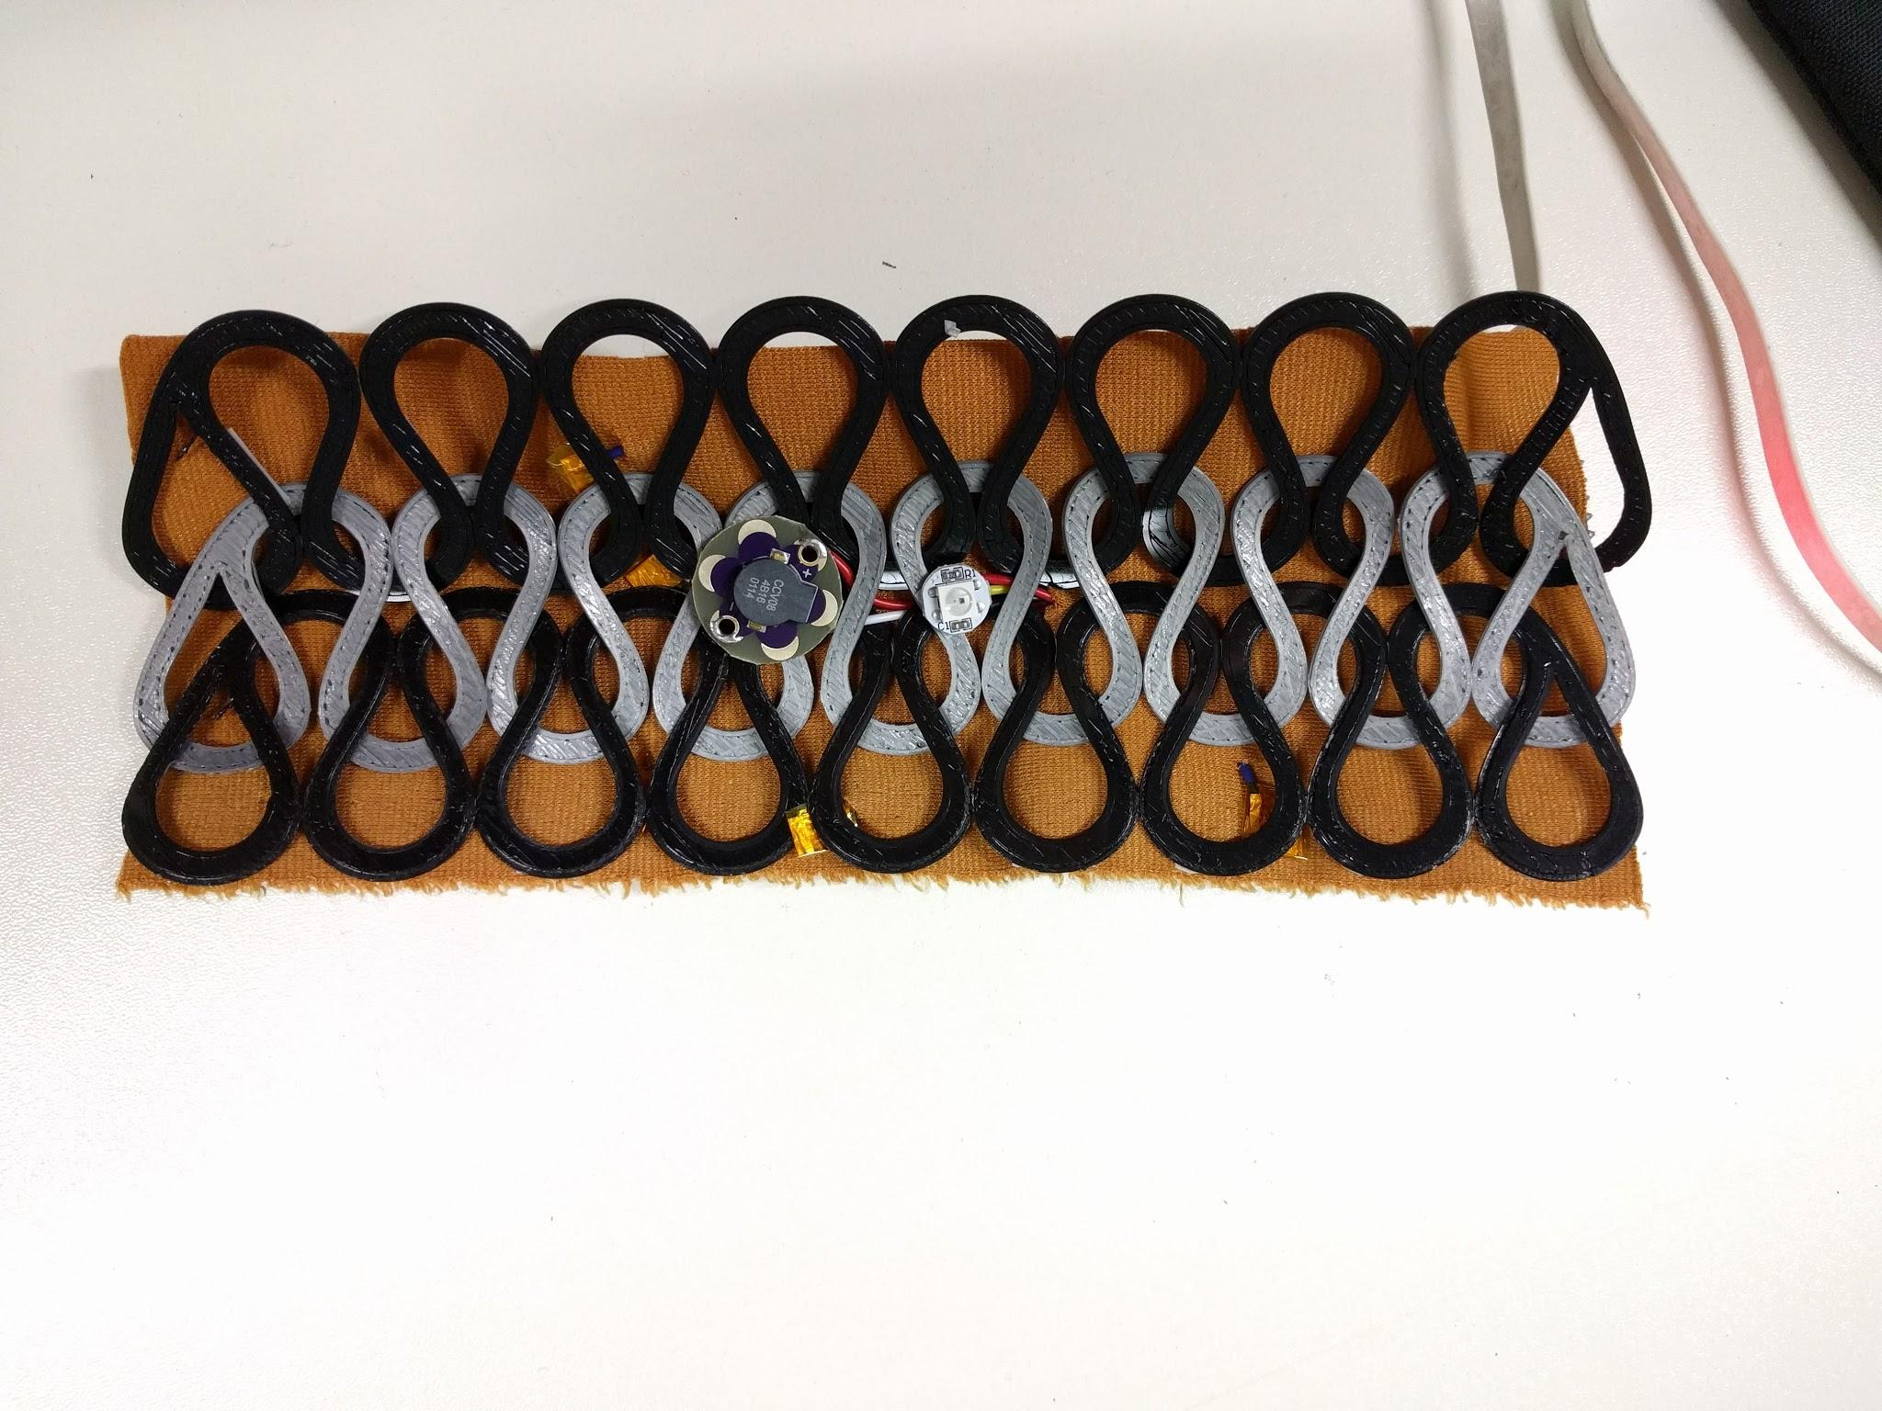

Photo 5.6: Wristband with 3D printed patterns, loudspeaker, Neopixel and sensors in front

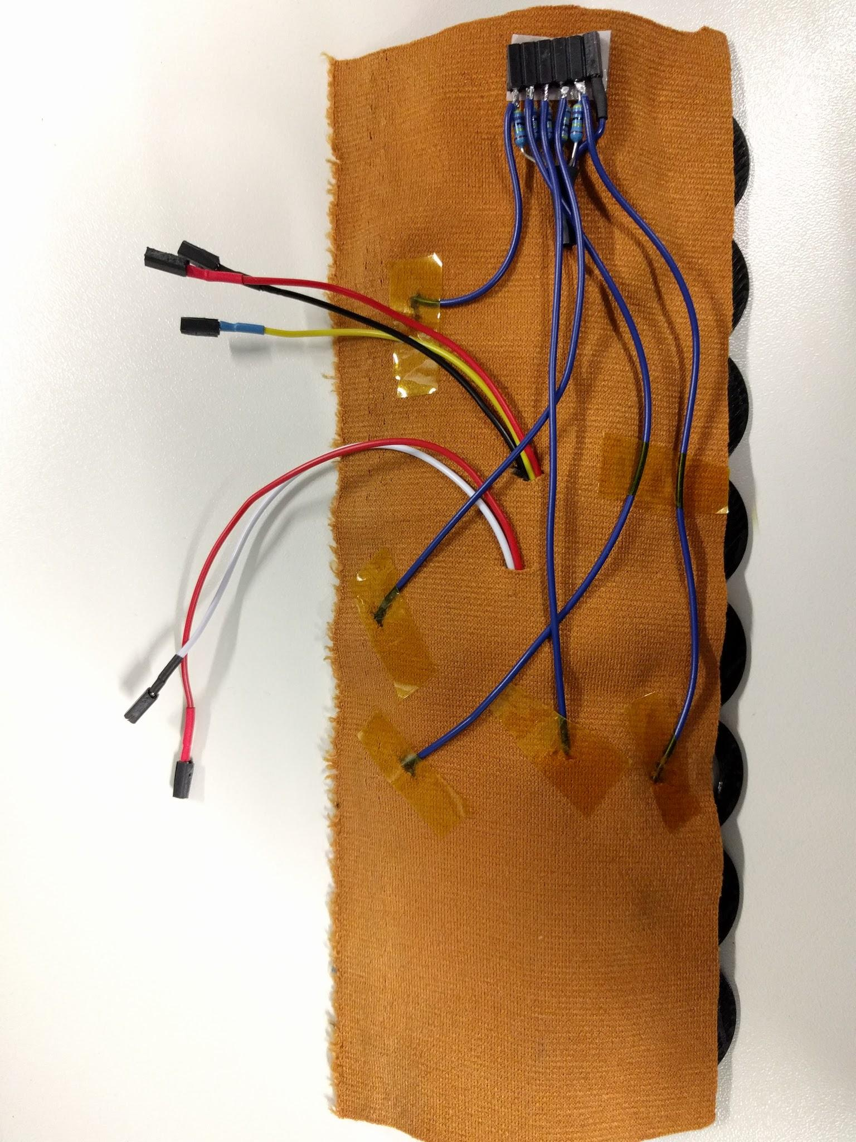

Photo 5.7: Wristband with wirings at the back

Finally I plugged in the microcontroller and it works! You can [watch the video here.](https://drive.google.com/open?id=17jjRXOXy5EPm3M8IK895Cn6DMMlIN-BV-g)

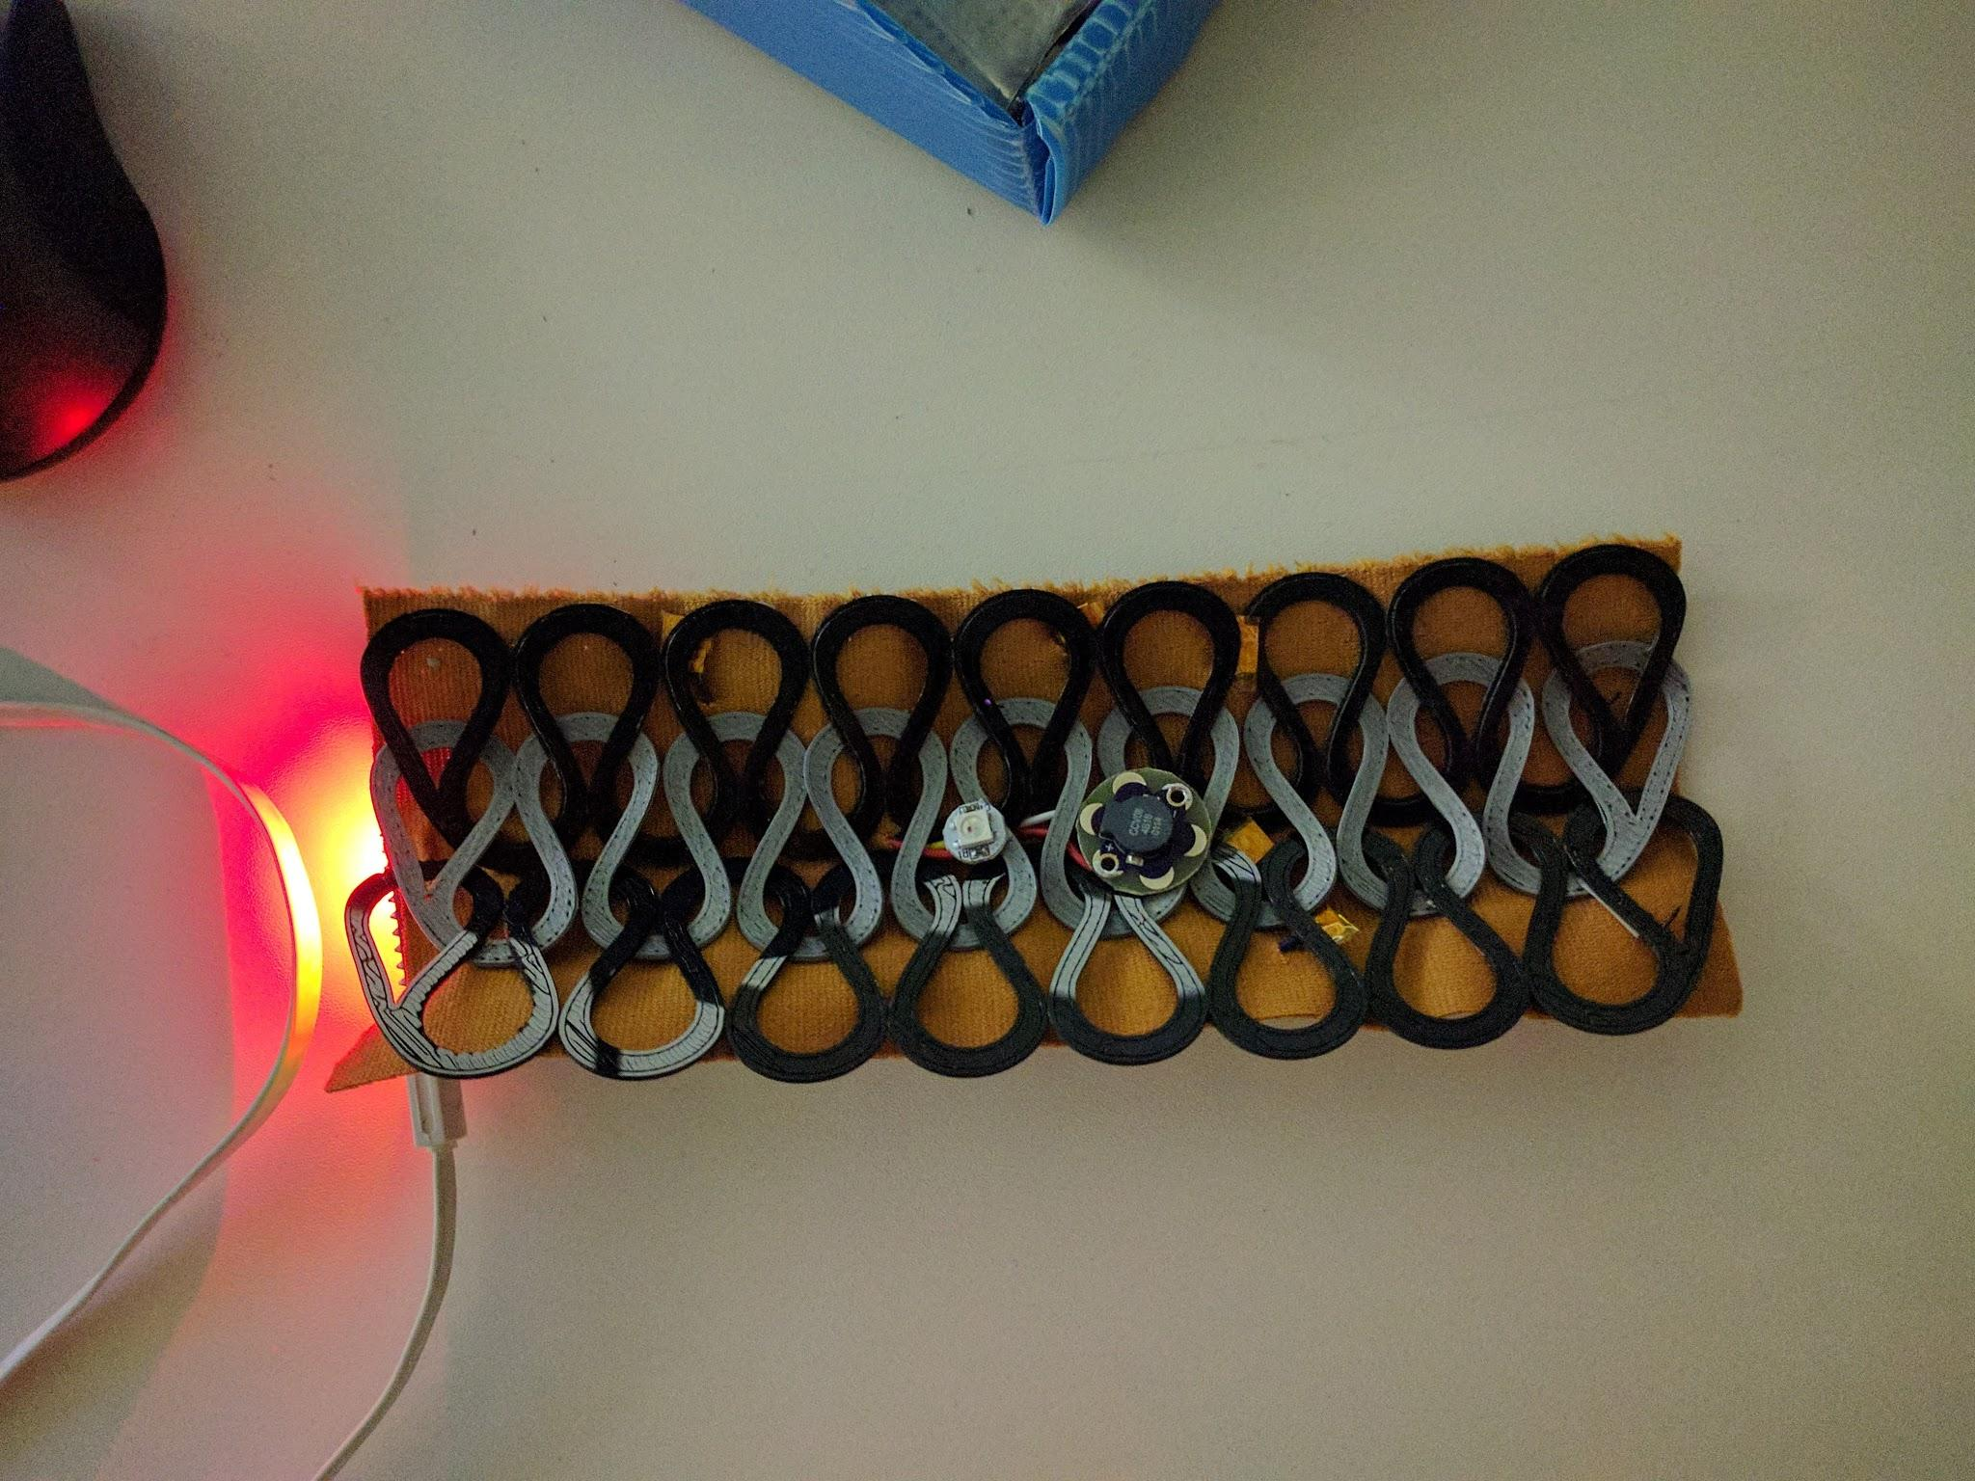

Photo 5.8: Musical wristband prototype tested working

However, there is a lot that can be improved to the wristband to make it more attractive or simply more wearable-friendly. For example, some patterns can be embroidered on the textile using conductive thread to act as touch spots for capacitive sensors, which I intended to do but did not have enough time for. Also, more can be added to the design of the wristband so that the electronics parts can be mounted nicely. This is why I decide to continue with the project even after the end of the bootcamp to see how much nicer I can make it to appear.

## 

## 

## 27.02.2017 - Day 6: Improvement of final project “Interactive musical wristband version 2”

I revised the design of the wristband to ensure both aesthetics and functionality:

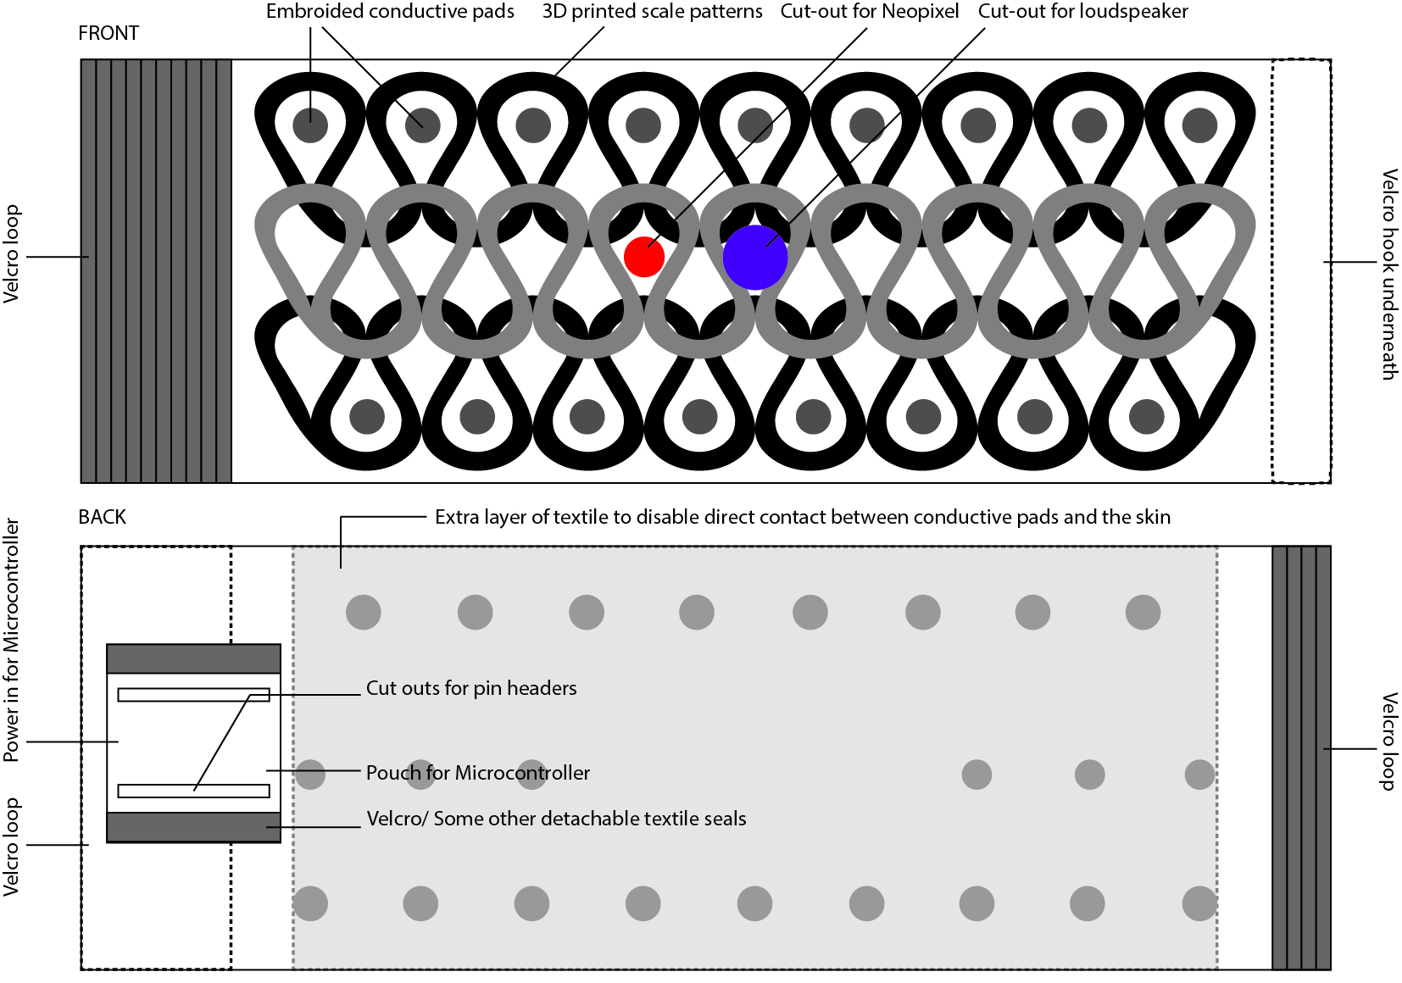

Photo 6.1: Revised design of the wristband with additional parts such as embroidered conductive pads, velcros, pouch to hold microcontroller

I started the day by embroidering conductive pads on the textile to serve as the interface for touching:

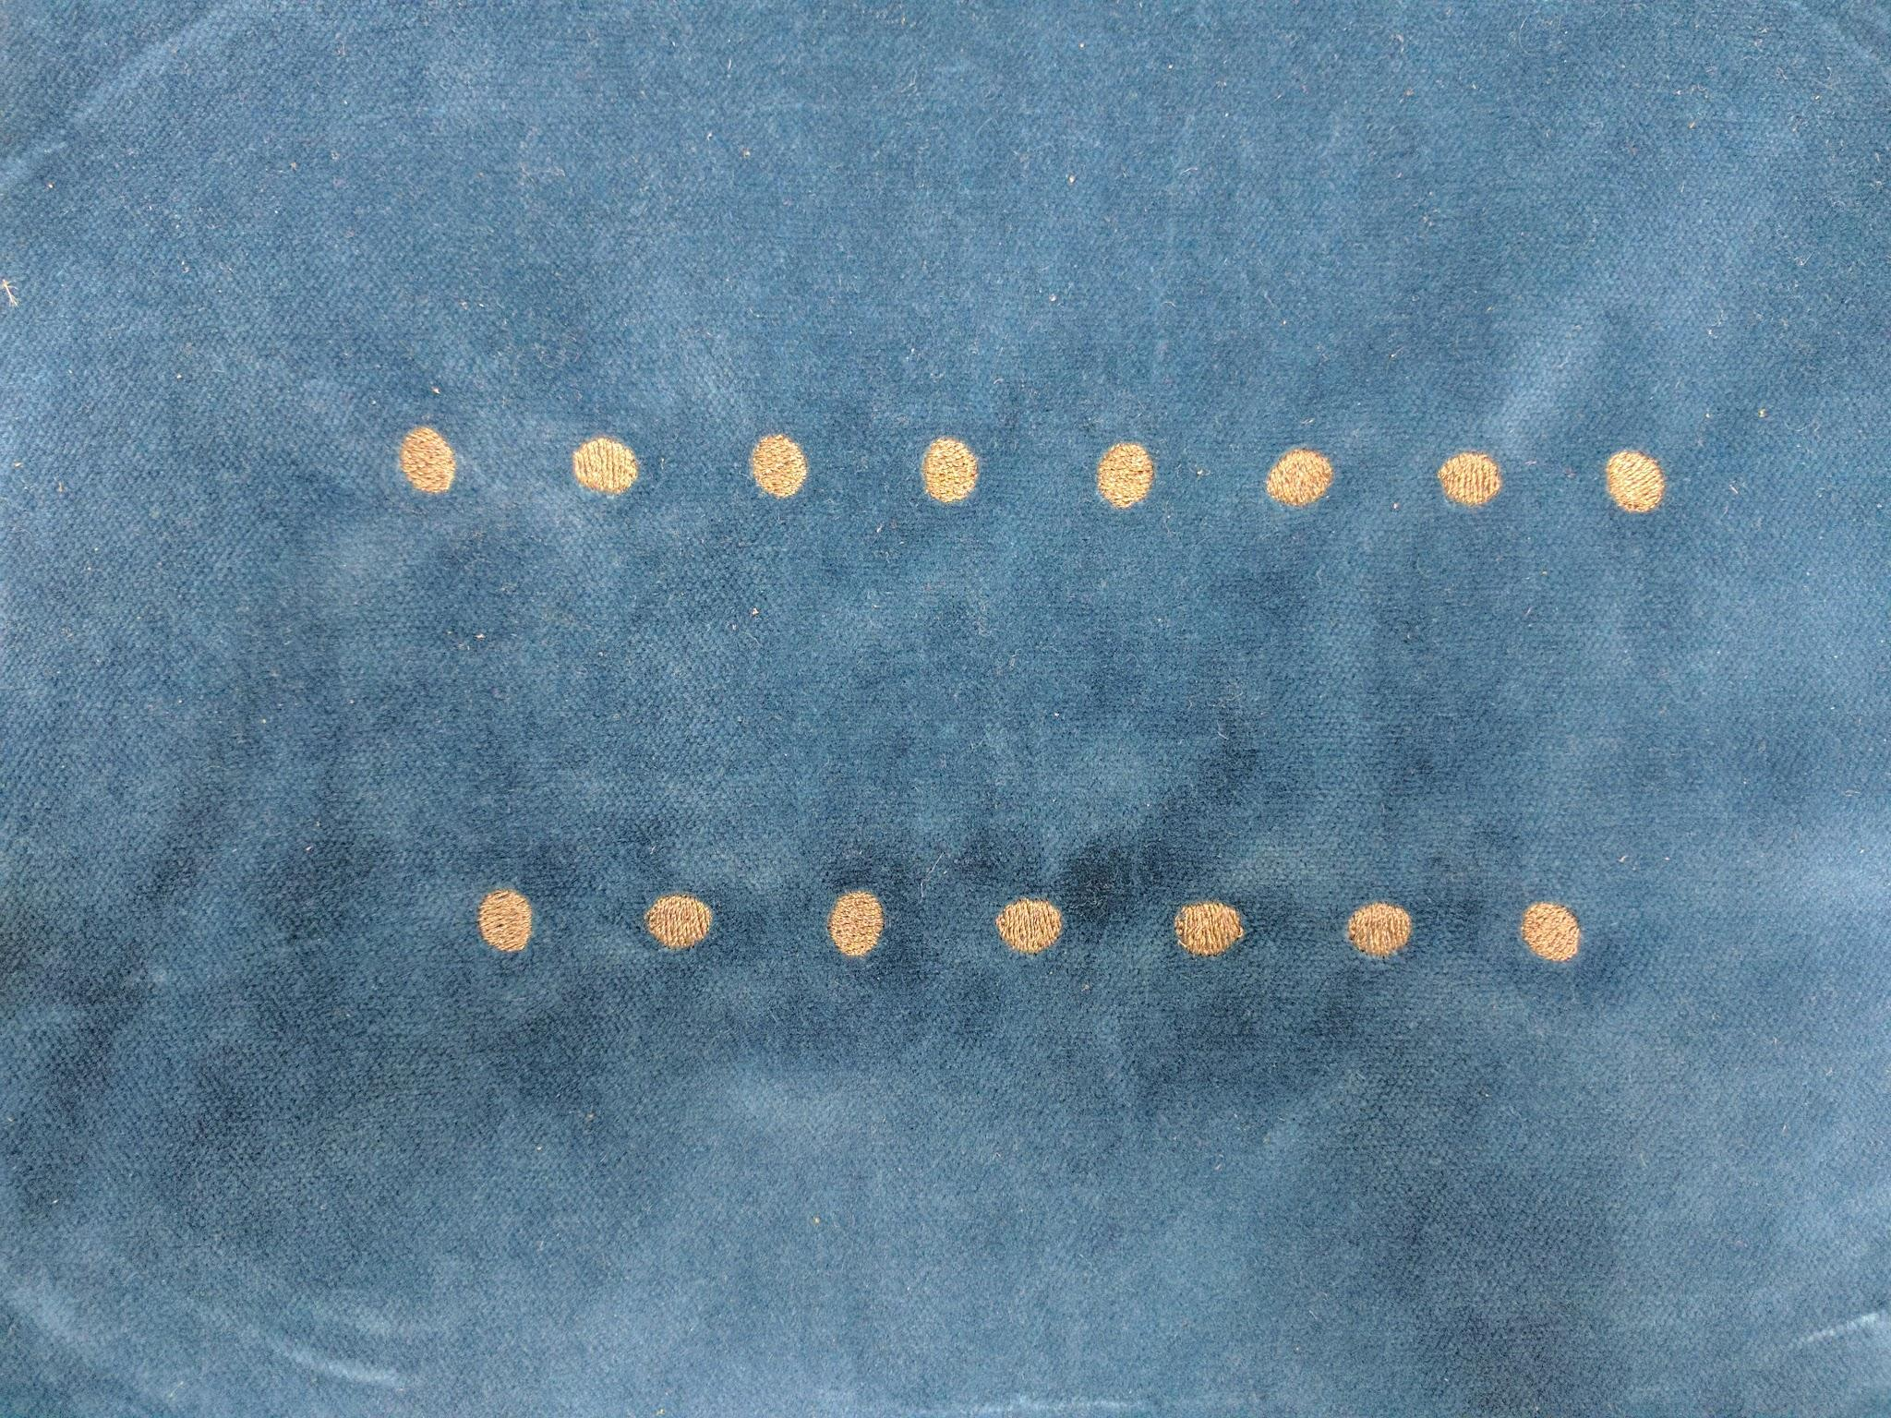

Photo 6.2: Touch spots embroidered on textile using conductive thread for the new wristband

Next, I sewed in the velcros and the pocket for the microcontroller

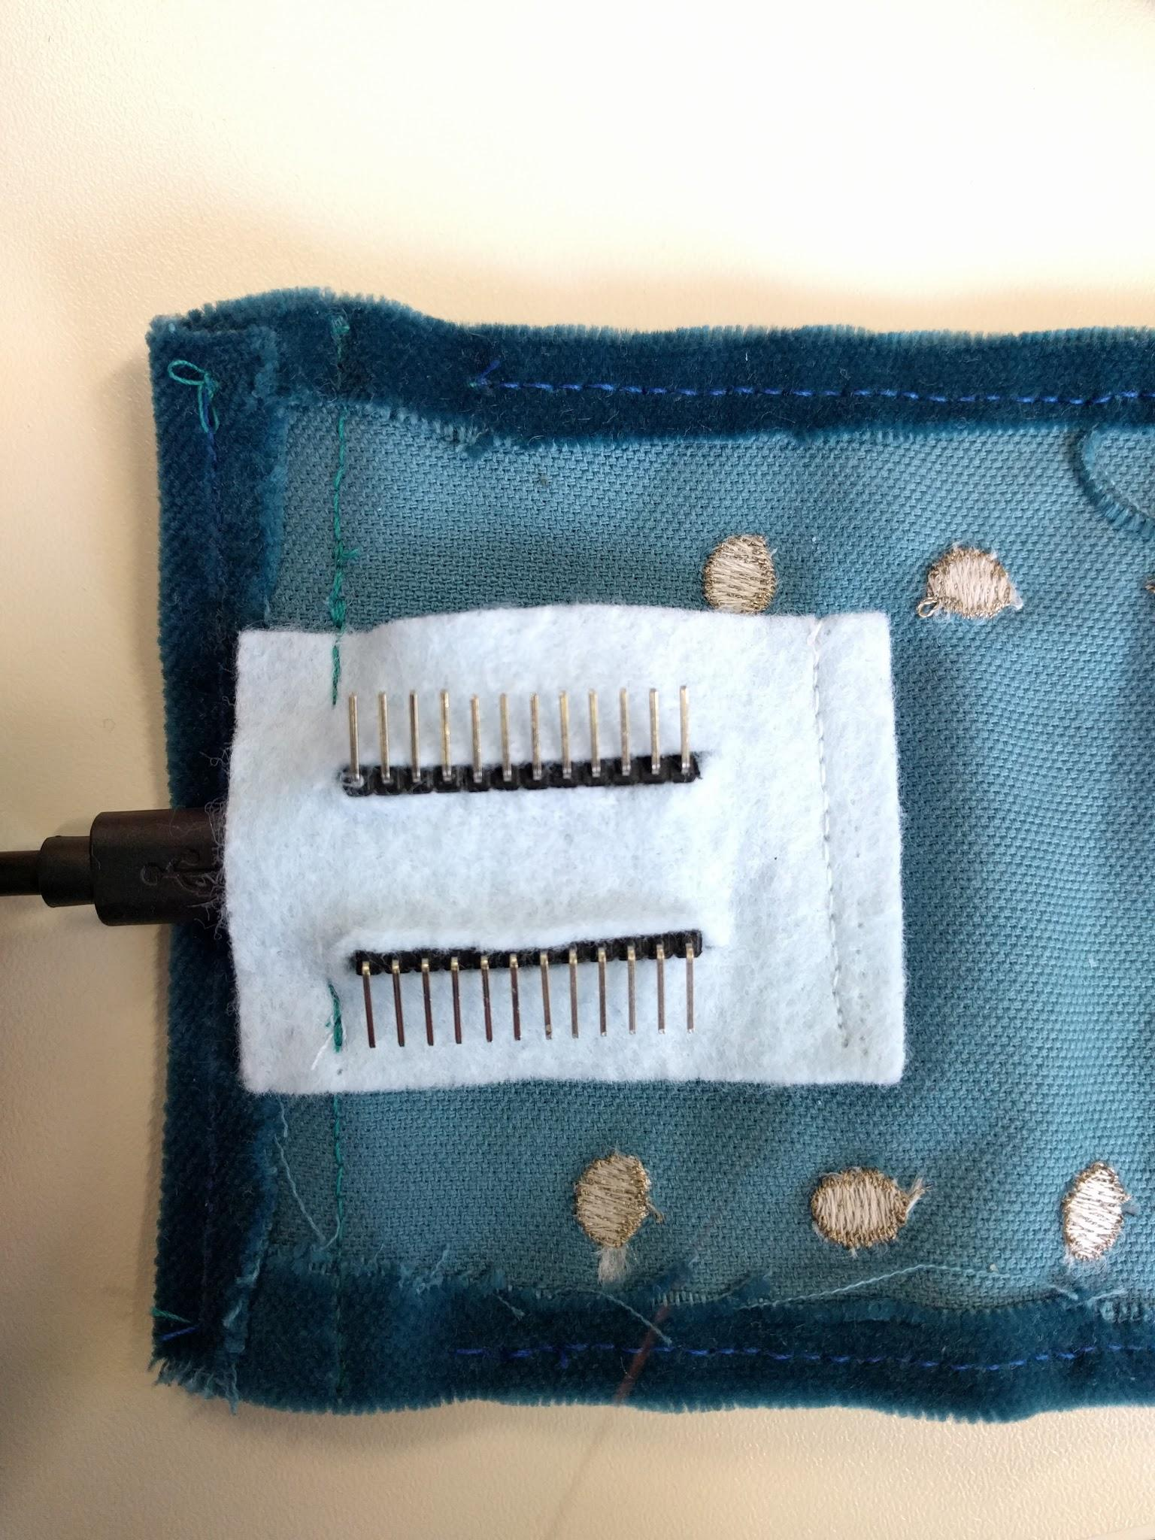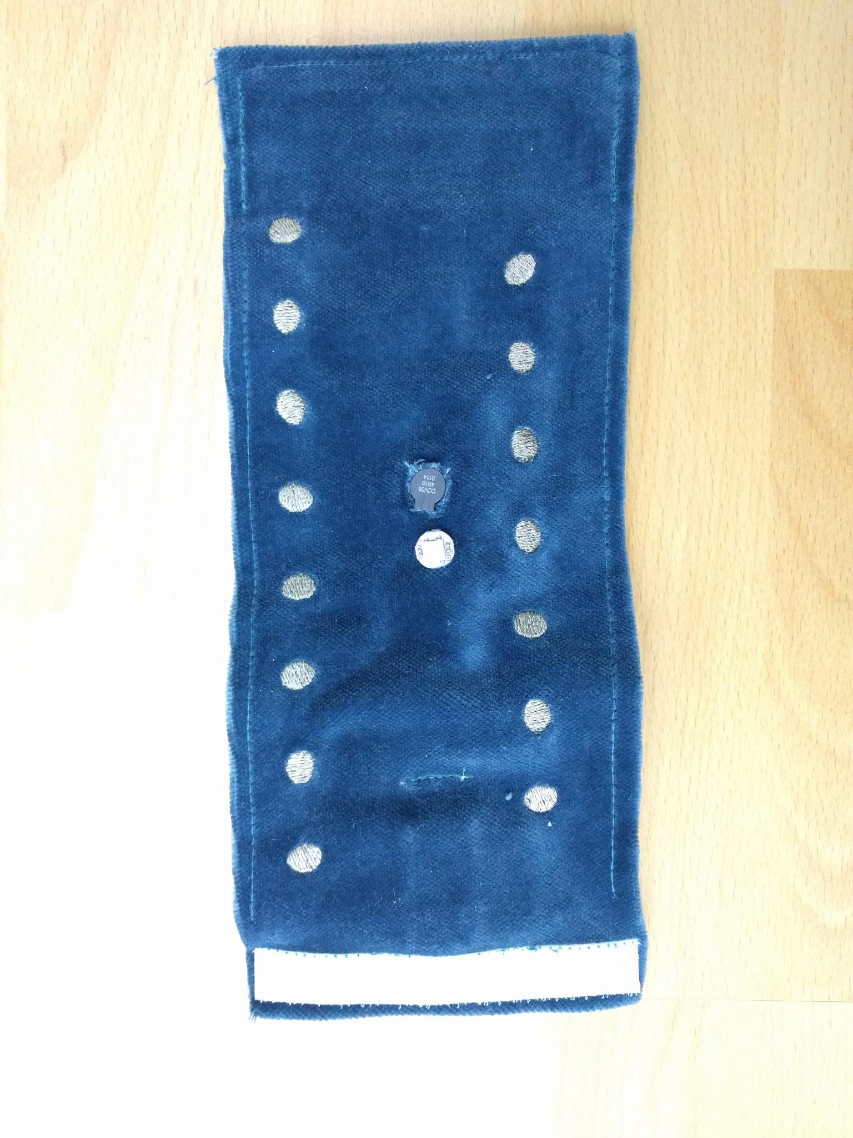

Photo 6.3a-6.3b: Sewing microcontroller pocket to the back and velcros to both sides of the new wristband

And then I mounted the 3D patterns, the Neopixel and the loudspeaker to the front of the wristband like before

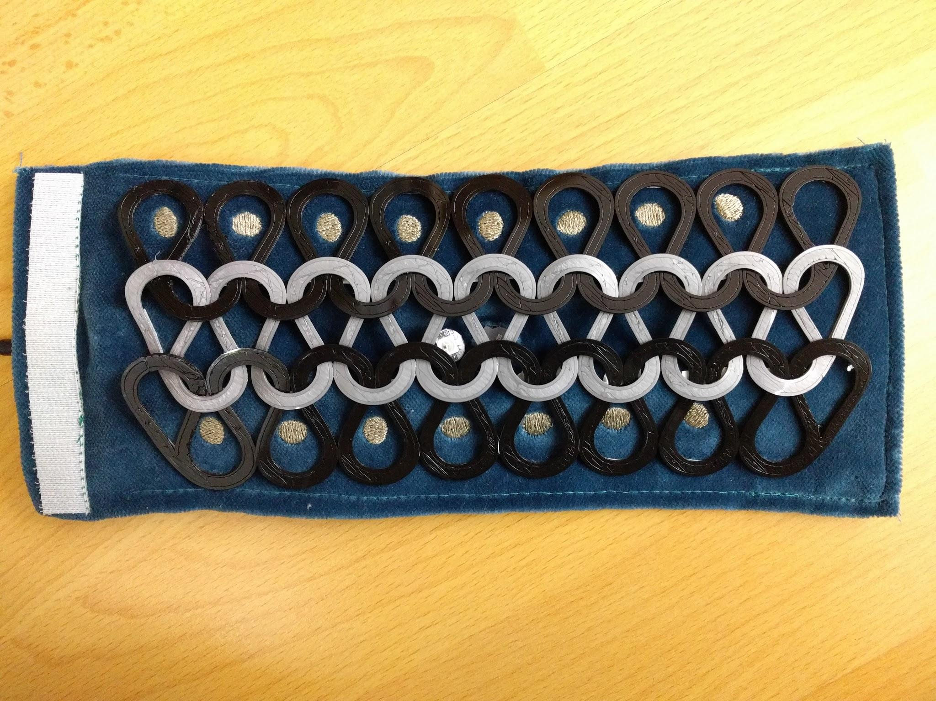

Photo 6.4: Mounting the 3D printed patterns, Neopixel and loudspeaker onto the new wristband

I also added more sensors to allow the new wristband to play more notes than the previous version.

Finally I assemble the electronics and test run it.

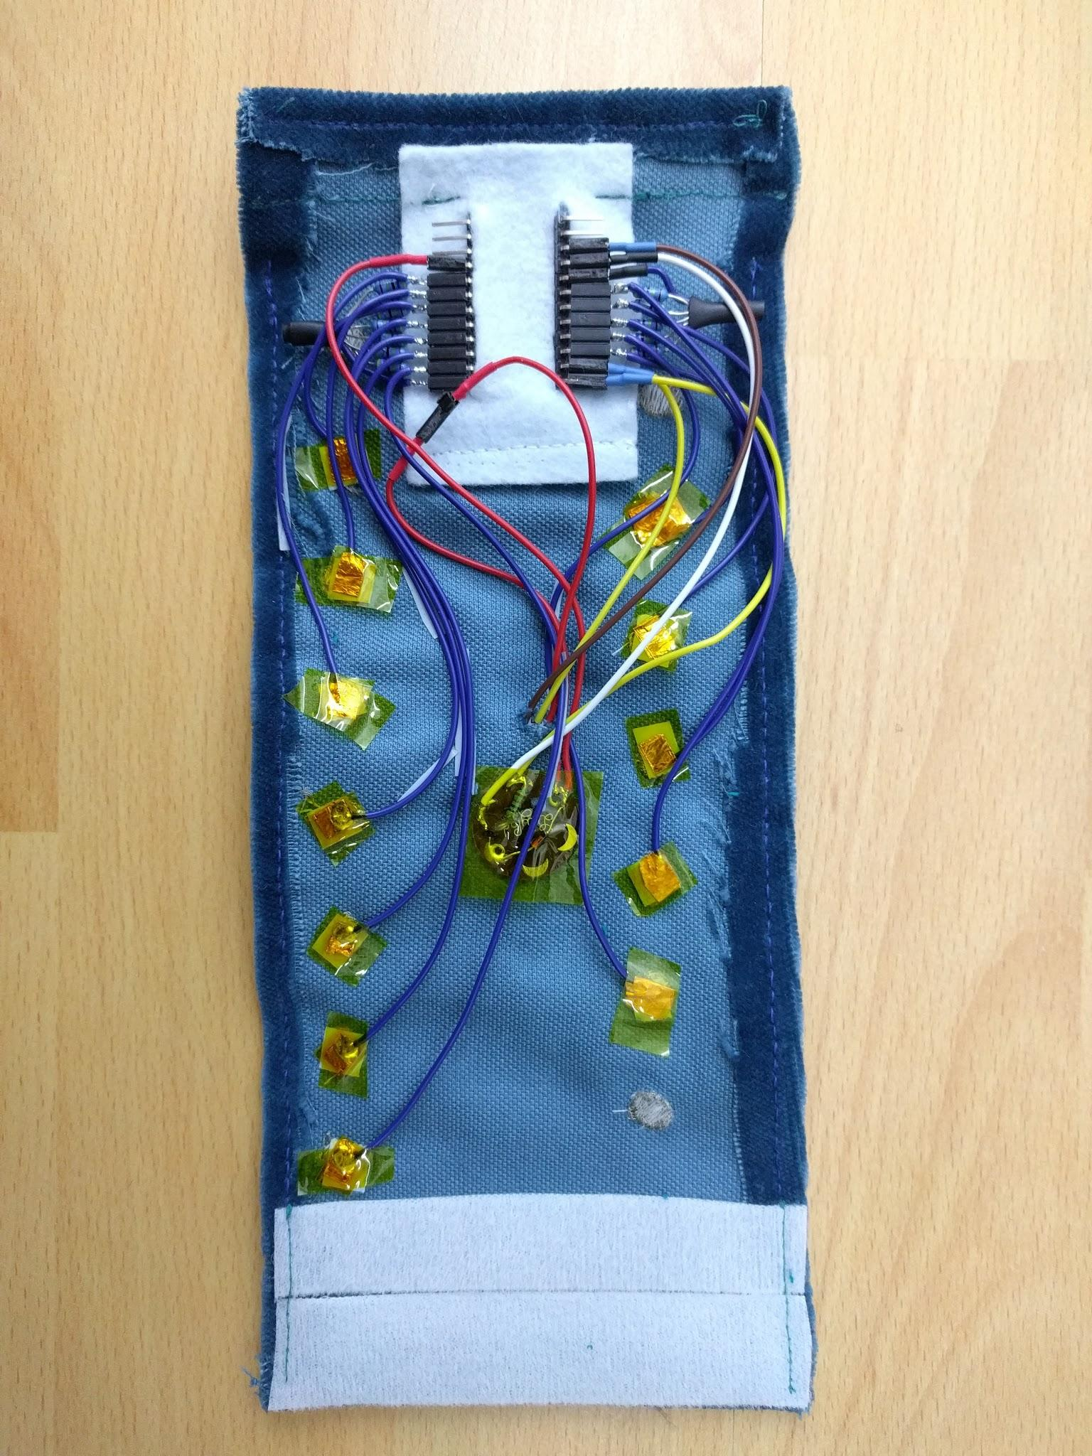

Photo 6.5: Mount the electronics on the back side of the new wristband

And it works too, yay! Now I can play some songs, or at least [the Happy Birthday song](https://drive.google.com/open?id=1Z6S9Ow4DFeNC1pcFJgWmBOpGZVO2vQA2ew) with it.

But I used some cheatsheet for the musical notes :D :D :D

And no worries because the note for each sensor can all be redefined in the [final sketch](https://drive.google.com/open?id=0B77ddV_s5oS_U2N2VzhMVVVORmM).

And this is how it looks like on your wrist:

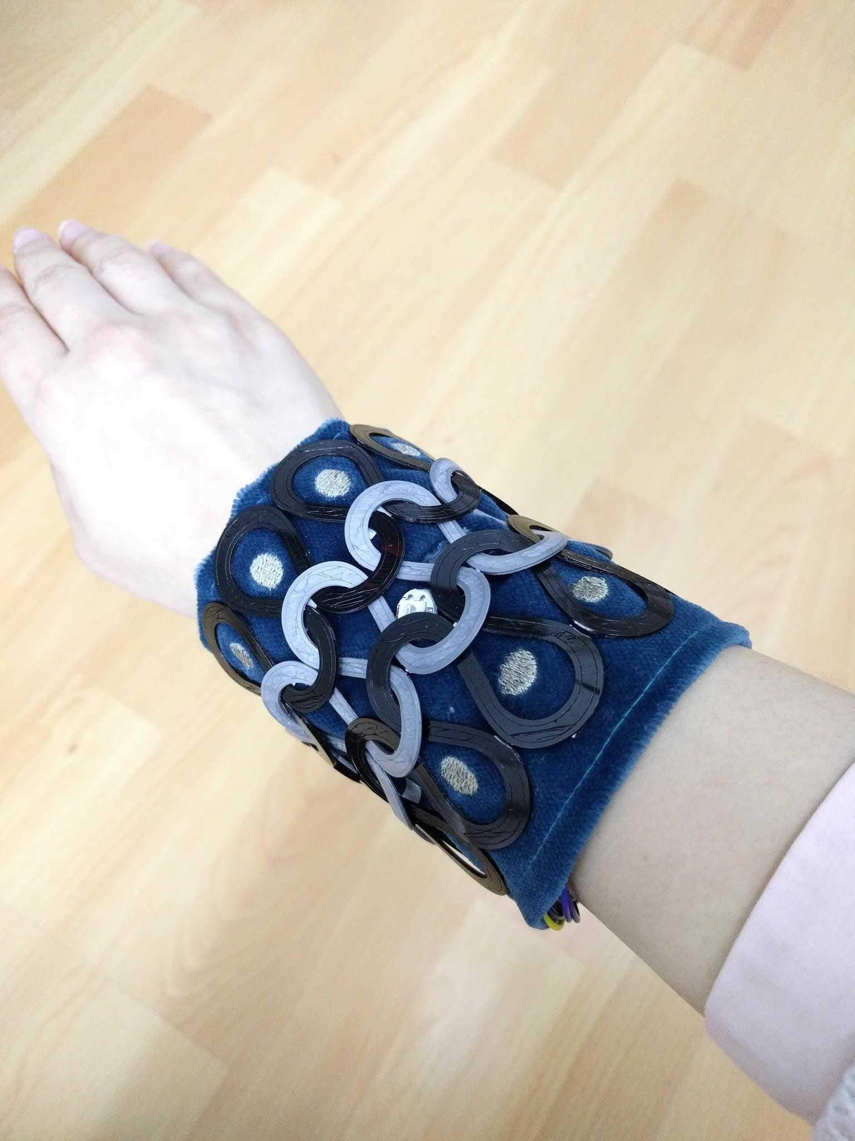

END OF DOCUMENTATION.